TESTQ-RTM: MACHINE LEARNING-BASED TEST QUALITY PREDICTION AND A LIVE REQUIREMENTS TRACEABILITY MATRIX FOR END-TO-END QA AUTOMATION

INDIVIDUAL THESIS

Rashani K.G.M.
(IT22182678)
Individual component: Test Quality Prediction and Requirements Traceability Matrix (TestQ-RTM)
Group ID: R26-SE-039

Report submitted in partial fulfilment of the requirements for the
B.Sc. (Hons) Degree in Information Technology
Specialising in Software Engineering
Department of Software Engineering
Sri Lanka Institute of Information Technology
Sri Lanka
October 2026

DECLARATION AND SUPERVISOR CERTIFICATION
Candidate declaration. I declare that this thesis is my own work and does not incorporate, without acknowledgement, material previously submitted for a degree or diploma at any university or institute of higher learning. To the best of my knowledge, it contains no material previously published or written by another person except where acknowledgement is made in the text. I grant the Sri Lanka Institute of Information Technology the non-exclusive right to reproduce and distribute this thesis, in whole or in part, in print, electronic, or other media, while retaining the right to use the content in future work.
Academic integrity and AI disclosure. I have disclosed all use of generative AI and other automated tools in accordance with the module policy (Appendix B). I remain responsible for the accuracy, originality, citations, code, data, analyses, and conclusions in this thesis.
Student name: Rashani K.G.M.
Student ID: IT22182678
Signature: ______________________________ Date: ____________

Supervisor certification. The above candidate carried out this research for the bachelor's degree thesis under my supervision.
Role and name | Signature | Date
Supervisor: Ms. Suriyaa Kumari
Co-supervisor: Mr. Eishan Weerasinghe

ABSTRACT
Quality Assurance (QA) teams cannot judge whether a test case is well designed before it is executed, and the Requirements Traceability Matrices (RTMs) they rely on are maintained by hand and quickly become outdated, hiding coverage gaps, redundant tests, and weak tests. Existing research treats test quality, traceability, coverage analysis, and test-suite optimisation separately, and no reviewed approach predicts the design quality of natural-language Gherkin test cases before execution while connecting that prediction to requirement coverage. This thesis presents TestQ-RTM, Component 4 of the NextGen QA platform (R26-SE-039). Following a design science approach, TestQ-RTM was built as a FastAPI microservice with a React interface that assembles a live RTM on every request from the requirements and acceptance criteria of Component 1 and the Gherkin test cases and execution results of Component 2. Ten features extracted from Given/When/Then text and acceptance-criterion linkage drive an explainable weighted quality score and a tuned Random Forest classifier that labels each test High, Medium, or Low, with execution outcome excluded from the label. The service also ranks acceptance-criterion-level coverage gaps with a five-factor risk score, generates tests for uncovered criteria, rewrites and re-scores weak tests, classifies the test portfolio, and measures code coverage through a GitHub-integrated agent. On 200 held-out cases from a predominantly synthetic 1,000-sample dataset, the model achieved 98.0% accuracy, a macro F1-score of 0.977, and a precision of 1.00 for low-quality tests, with predictions in about 3 ms. An automated suite of 73 tests passed 71, including nine live end-to-end checks against Components 1 and 2; the two failures showed that the improvement step does not preserve the original test steps. The individual contribution is an integrated, explainable quality-and-traceability service, and validation on real, expert-labelled project data is the principal next step.
Keywords: test quality prediction, requirements traceability matrix, random forest, Gherkin, coverage gap detection

ACKNOWLEDGEMENTS
I extend my sincere gratitude to my supervisor, Ms. Suriyaa Kumari, and my co-supervisor, Mr. Eishan Weerasinghe, for their guidance, constructive feedback, and continuous encouragement throughout this research. Their expertise in software engineering and quality assurance directly shaped the direction and evaluation of this work.
I thank the members of my research group (R26-SE-039) for their collaboration in developing the NextGen QA platform. Access to the live services and data contracts of Components 1 and 2 made it possible to build and evaluate a live, end-to-end traceability solution rather than an isolated prototype.
I also acknowledge the open-source communities behind FastAPI, SQLAlchemy, scikit-learn, pytest, and React, whose tools formed the technical foundation of this work. No external funding was received for this research. Finally, I thank my family for their patience and unwavering support.

TABLE OF CONTENTS
1 INTRODUCTION 1
1.1 Overall project context 1
1.2 Individual component context 2
1.3 Problem statement 3
1.4 Research gap 4
1.5 Aim and objectives 5
1.6 Research questions or hypotheses 6
1.7 Scope limitations and assumptions 7
1.8 Individual contribution 7
1.9 Thesis structure 8
2 LITERATURE REVIEW AND RELATED WORK 9
2.1 Review method and scope 9
2.2 Domain and theoretical foundations 9
2.3 Related research 10
2.4 Existing systems products and techniques 11
2.5 Gap synthesis and conceptual framework 12
3 RESEARCH METHODOLOGY 14
3.1 Research design 14
3.2 Data participants or study materials 14
3.3 Experimental or study procedure 16
3.4 Measures and evaluation metrics 16
3.5 Data analysis 17
3.6 Ethics privacy security and responsible AI 17
3.7 Reproducibility and research artefacts 18
4 PRODUCT AND SOLUTION DESIGN 20
4.1 Requirements 20
4.2 Component architecture within the complete solution 21
4.3 Design alternatives and decisions 23
4.4 Detailed design 24
4.5 Standards and professional practice 32
5 IMPLEMENTATION INTEGRATION AND TESTING 34
5.1 Development environment and technology stack 34
5.2 Component implementation 34
5.3 Integration with the other components 37
5.4 Verification and software testing 37
5.5 Deployment and operation 43
6 RESULTS AND VALIDATION 45
6.1 Research results 45
6.2 Product and technical results 47
6.3 User or stakeholder validation 49
6.4 Integration results 50
6.5 Summary of findings 51
7 DISCUSSION 54
7.1 Interpretation of findings 54
7.2 Comparison with literature baselines and existing solutions 54
7.3 Research contribution 55
7.4 Product contribution 55
7.5 Limitations and threats to validity 55
7.6 Implications 56
8 COMMERCIALISATION AND SUSTAINABILITY 57
8.1 Value proposition and target users 57
8.2 Market and competitive position 57
8.3 Business or sustainability model 57
8.4 Scalability intellectual property and compliance 58
8.5 Contribution to the Sustainable Development Goals 59
9 CONCLUSION AND FUTURE DIRECTIONS 60
9.1 Conclusion 60
9.2 Achievement of objectives 60
9.3 Individual research and product contributions 61
9.4 Future directions 61
REFERENCES 62
GLOSSARY 65
APPENDICES 66
Appendix A Research instruments or extended results 66
Appendix B Academic integrity and AI use disclosure 67

LIST OF FIGURES
Figure 3.1: Dataset Construction and Model Training Workflow 15
Figure 3.2: Quality-Label Distribution in the Dataset 15
Figure 4.1: Overall NextGen QA System Architecture 22
Figure 4.2: TestQ-RTM Layered Architecture 23
Figure 4.3: Use Case Diagram for TestQ-RTM 25
Figure 4.4: Sequence Diagram – Loading the Live RTM Matrix 26
Figure 4.5: RTM Data Model – Live Joins and Persisted Entities 27
Figure 4.6: Test-Case Quality Prediction Pipeline 28
Figure 4.7: Coverage-Gap Detection and Risk-Based Prioritisation 30
Figure 4.8: Intelligent Test Improvement Loop 31
Figure 4.9: GitHub Code-Coverage Analysis Agent 32
Figure 6.1: Confusion Matrix on the Held-Out Test Set 46
Figure 6.2: Per-Class Precision, Recall, and F1-Score 46
Figure 6.3: Random Forest Feature Importances 47
Figure 6.4: Correlation of Each Feature with the Quality Label 47
Figure 6.5: Risk-Factor Breakdown for Three Validation Scenarios 48
Figure 6.6: Measured Effect of the Improvement Loop 48

LIST OF TABLES
Table 1.1: Components of the NextGen QA Platform 2
Table 1.2: Comparison of Existing Approaches with TestQ-RTM 4
Table 1.3: SMART Criteria Applied to the Research Objectives 6
Table 2.1: Existing Tools and Techniques and Their Limitations 12
Table 2.2: Mapping of Research Gaps to Design Responses and Research Questions 13
Table 3.1: Evaluation Measures 17
Table 3.2: Research Artefacts 19
Table 4.1: Design Alternatives and Decisions 24
Table 4.2: Extracted Test-Case Quality Features 27
Table 5.1: TestQ-RTM Technology Stack 34
Table 5.2: TestQ-RTM REST API Endpoint Summary 36
Table 5.3: Test Case – Quality Prediction for a Well-Designed Test Case 38
Table 5.4: Test Case – Quality Prediction for a Deficient Test Case 39
Table 5.5: Test Case – Independence of Quality from Execution Outcome 39
Table 5.6: Test Case – Acceptance-Criterion-Level Coverage 40
Table 5.7: Test Case – Risk Scoring of an Untested Must Requirement 40
Table 5.8: Test Case – Test Generation for an Uncovered Acceptance Criterion 41
Table 5.9: Test Case – Intelligent Improvement of a Low-Quality Test 41
Table 5.10: Test Case – Portfolio Classification 42
Table 5.11: Test Case – Weighted Code-Coverage Aggregation 42
Table 5.12: Automated Research Test Suite – Results of the Full Run 43
Table 6.1: Quality Model Performance Summary 45
Table 6.2: Manual User-Interface Checks 50
Table 6.3: Live End-to-End Integration Results 51
Table 6.4: Targets Versus Achieved Results 52
Table 8.1: Budget and Resource Justification (Research Scale) 58
Table 9.1: Achievement of the Research Objectives 60
Table B.1: Use of Generative AI Tools 68

LIST OF ABBREVIATIONS
Abbreviation | Meaning
AC | Acceptance Criterion / Criteria
API | Application Programming Interface
BDD | Behaviour-Driven Development
C1–C4 | NextGen QA Components 1 to 4
CI/CD | Continuous Integration / Continuous Deployment
CSV | Comma-Separated Values
CV | Cross-Validation
DSR | Design Science Research
E2E | End-to-End
F1 | Harmonic mean of precision and recall
FR | Functional Requirement
IP | Intellectual Property
JSON | JavaScript Object Notation
JWT | JSON Web Token
ML | Machine Learning
MoSCoW | Must, Should, Could, Won't (prioritisation scheme)
NFR | Non-Functional Requirement
NLP | Natural Language Processing
ORM | Object-Relational Mapping
PAT | Personal Access Token
PDPA | Personal Data Protection Act
QA | Quality Assurance
REST | Representational State Transfer
RF | Random Forest
RQ | Research Question
RTM | Requirements Traceability Matrix
SaaS | Software as a Service
SDG | Sustainable Development Goal
SMART | Specific, Measurable, Achievable, Relevant, Time-bound
STLC | Software Testing Lifecycle
UI | User Interface

1 INTRODUCTION
Software testing is one of the most resource-intensive phases of the software development lifecycle, and it is frequently reported to consume between 30% and 40% of total project effort. Despite this investment, QA teams routinely face two fundamental difficulties. First, the effectiveness of a test case is usually discovered only after it has been executed: a vague, incomplete, or weakly asserted test can pass for months while providing little real protection. Second, the relationship between requirements and tests is rarely visible in real time. Requirements Traceability Matrices (RTMs), the standard instrument for answering the questions “Is requirement R tested?” and “Which tests cover requirement R?”, are typically maintained by hand and become outdated as soon as requirements or tests change [1], [2]. This chapter introduces the overall project, the individual component that is the subject of this thesis, and the problem, gap, objectives, and research questions that guided the work.

1.1 Overall project context
NextGen QA (project R26-SE-039) is an end-to-end framework that automates the Software Testing Lifecycle (STLC), from requirements captured in sprint meetings to executed test reports. It consists of four integrated components, summarised in Table 1.1. Component 1 (C1) converts sprint-meeting transcripts into structured requirements, user stories, and acceptance criteria; Component 2 (C2) generates Gherkin test scenarios and executable test code and runs them through CI/CD; Component 3 (C3) provides self-healing test automation for failed runs; and Component 4 (C4) provides test quality prediction and requirements traceability. All components are exposed to a single React frontend through an API gateway that verifies JSON Web Tokens (JWTs) issued by a shared authentication service.
Table 1.1: Components of the NextGen QA Platform
Component | Responsibility | Main outputs consumed by C4
C1 – Requirements | Extracts requirements, user stories, and acceptance criteria from meeting transcripts | Requirements, user stories, MoSCoW priorities, acceptance criteria
C2 – Test generation and execution | Generates Gherkin scenarios and test code, and executes test suites | Gherkin test cases, test suites, execution results, repository link
C3 – Self-healing | Repairs broken test automation after failed runs | Not consumed directly
C4 – TestQ-RTM (this thesis) | Predicts test quality and maintains a live RTM | Quality scores, RTM, gaps, risk, portfolio insights

1.2 Individual component context
This thesis focuses on Component 4, referred to as TestQ-RTM. TestQ-RTM is implemented as an independent Python FastAPI microservice that sits downstream of C1 and C2. Rather than copying their data into a separate store, it reads requirements and test cases live from their APIs, scoped by the project and iteration the user has open, and computes the traceability matrix, quality predictions, coverage gaps, risk scores, and portfolio insights on demand. As a result, the RTM is always consistent with the current state of the project and requires no manual maintenance.
Test design quality has long been recognised as a determinant of defect-detection capability. Well-designed test cases state their preconditions explicitly, describe the action under test precisely, and assert a concrete expected result. Poorly designed test cases omit one or more of these elements, rely on vague wording such as “works properly” or “appropriate response”, and are only loosely connected to the requirement they claim to verify. In Behaviour-Driven Development (BDD), these elements map directly onto the Given, When, and Then steps of a Gherkin scenario [3], [4], which makes the structure of a test case observable in its text before it is ever executed. Because C2 generates test cases automatically from user stories, an obvious question arises within the platform: how good are the generated tests, and which requirements do they actually cover? TestQ-RTM answers this question continuously and without manual review.

1.3 Problem statement
Software organisations invest heavily in testing, yet they continue to face persistent difficulties in ensuring test quality and maintaining traceability between requirements and tests. In an automated pipeline such as NextGen QA, where requirements are extracted from meetings and test cases are generated by software, these difficulties become more acute: the volume of artefacts grows quickly, and no human has written or reviewed every test case. In current practice, QA engineers review test cases manually, typically requiring one to two hours per twenty tests, and build RTMs in spreadsheets, typically requiring two to three hours per project. Coverage gaps are found by manual inspection, and decisions about which tests to keep, fix, or retire are made subjectively. These processes are slow, error-prone, and unsustainable in agile environments with frequent change.
The central research problem addressed in this thesis is:
“How can an automated system predict the design quality of test cases before execution and maintain a live, acceptance-criterion-level requirements traceability matrix that detects, prioritises, and helps resolve coverage gaps and test-portfolio inefficiencies, while integrating seamlessly into an end-to-end QA automation platform?”
This problem can be further decomposed into the following dimensions:
- Unknown test effectiveness before execution: low-quality tests consume execution resources, give false confidence, and cannot be filtered or prioritised because their quality is unknown until they fail to catch a defect.
- Unknown requirement coverage: teams cannot reliably state which requirements, and which acceptance criteria within them, are verified by which tests, nor whether those tests are currently passing.
- Undetected and unprioritised coverage gaps: even with code coverage available, untested requirements, partially tested acceptance criteria, and requirements covered only by failing or weak tests remain hidden, and there is no objective basis for deciding which gap to address first.
- Inefficient test portfolios: test suites accumulate near-duplicate tests, sole tests protecting critical requirements go unrecognised, and weak tests are retained despite providing little value.
- Manual, disconnected tooling: quality review, traceability, coverage measurement, and optimisation are performed in separate tools that do not share a consistent view of the project.

1.4 Research gap
A review of the literature and of industry tools (Chapter 2) reveals that test quality assessment, requirements traceability, coverage gap analysis, and portfolio optimisation have progressed along largely separate tracks. Table 1.2 compares representative approaches with TestQ-RTM across the capabilities addressed in this research.
Table 1.2: Comparison of Existing Approaches with TestQ-RTM
Approach | Quality score | Before execution | Live RTM | AC coverage | Risk ranking | Gap test generation | Portfolio
Athanasiou et al. [5] | ✓ | ✗ | ✗ | ✗ | ✗ | ✗ | ✗
Hauptmann et al. [6] | Partial | ✗ | ✗ | ✗ | ✗ | ✗ | ✗
Grano et al. [7] | ✗ | ✓ | ✗ | ✗ | ✗ | ✗ | ✗
Spieker et al. [8] | ✗ | ✗ | ✗ | ✗ | ✗ | ✗ | Partial
Guo et al. / Lin et al. [9], [10] | ✗ | ✗ | Partial | ✗ | ✗ | ✗ | ✗
Yoo and Harman [11] | ✗ | ✗ | ✗ | ✗ | ✗ | ✗ | ✓
Jira/Xray, TestRail (commercial) | ✗ | ✗ | Partial | Partial | ✗ | ✗ | ✗
TestQ-RTM (this research) | ✓ | ✓ | ✓ | ✓ | ✓ | ✓ | ✓

Three gaps follow from this comparison. First, no reviewed approach predicts the design quality of individual natural-language (Gherkin) test cases before execution, while also explaining which specific weaknesses lowered the score. Second, traceability approaches recover or record links, but they do not measure whether a linked test covers every acceptance criterion, and the resulting matrices are not continuously synchronised with the systems that own requirements and tests. Third, coverage-gap reporting and test-suite optimisation are not driven by requirement priority and predicted test quality together, so teams receive lists of problems without a defensible order of priority or a concrete remedy.

1.5 Aim and objectives
Aim. To design, develop, and evaluate TestQ-RTM, an integrated service within the NextGen QA platform that predicts the design quality of test cases before execution using machine learning, and that maintains a live Requirements Traceability Matrix to detect, prioritise, and help resolve coverage gaps and test-portfolio inefficiencies.
The aim is achieved through the following objectives:
- O1 – Test-case quality prediction model: extract quality features from the Gherkin text of test cases and their linked acceptance criteria, and train and evaluate a machine learning classifier that assigns a 0–100 quality score and a High, Medium, or Low label before execution, targeting an accuracy of at least 85%.
- O2 – Live requirements traceability matrix: automatically construct and continuously maintain an RTM that links requirements, user stories, acceptance criteria, test cases, and execution status, without manual link maintenance.
- O3 – Coverage-gap detection and risk-based prioritisation: identify untested, partially tested, failing, unverified, and low-quality coverage at the level of individual acceptance criteria, and rank the resulting gaps with an explainable risk score.
- O4 – Intelligent test generation and improvement: generate test cases targeted at specific uncovered acceptance criteria, and recommend and apply improvements to low-quality test cases whose effect is verified by re-scoring them with the same model.
- O5 – Requirement-aware test portfolio optimisation: classify the live test portfolio into redundant, critical, and weak tests using traceability and predicted quality.
- O6 – Code-coverage and platform integration: measure statement and branch coverage of the project repository through a GitHub-integrated agent for Python, JavaScript/TypeScript, and Java, and expose all capabilities through REST APIs and a web dashboard integrated with the NextGen QA gateway.
Table 1.3 shows how the SMART criteria were applied to these objectives.
Table 1.3: SMART Criteria Applied to the Research Objectives
Criterion | Description | Application to TestQ-RTM
Specific | Clearly defined scope and deliverables | 10 extracted features, 3 quality classes, 5 risk factors, dedicated RTM pages, 20+ REST endpoints
Measurable | Quantifiable success criteria | Prediction accuracy ≥ 85%; Low-class precision ≥ 90%; per-prediction latency in milliseconds
Achievable | Feasible with available technology | FastAPI, scikit-learn, PostgreSQL, and React; no paid ML APIs required
Relevant | Addresses a genuine QA need | Replaces manual RTM upkeep and test review in the NextGen QA pipeline
Time-bound | Completed within the research timeline | Implemented and evaluated within the final-year research period

1.6 Research questions or hypotheses
The research problem and objectives were translated into the following research questions (RQs):
- RQ1: Can the design quality of a natural-language Gherkin test case be predicted before execution from features extracted from its text and its linkage to acceptance criteria, with an accuracy of at least 85% and without using the execution outcome as a proxy for quality? (O1)
- RQ2: Can an RTM be assembled live from the systems that own requirements and tests, so that it remains consistent with them without manual maintenance, while reporting coverage at the level of individual acceptance criteria? (O2, O6)
- RQ3: Can coverage gaps be detected and ranked by an explainable risk score that combines business priority, requirement coverage, execution results, predicted quality, and code coverage? (O3)
- RQ4: Can targeted test generation, model-verified test improvement, and requirement-aware portfolio analysis produce measurable improvements to a test suite? (O4, O5)

1.7 Scope limitations and assumptions
Scope. The research covers the design, implementation, and evaluation of Component 4 only. Requirements, user stories, and acceptance criteria are taken as produced by C1, and test cases, suites, and execution results as produced by C2; the quality of those upstream artefacts is outside the scope of this thesis. Test cases are assessed in their Gherkin (Given/When/Then) form. Code-coverage analysis is limited to Python, JavaScript/TypeScript, and Java projects hosted on GitHub.
Limitations. No public dataset of natural-language test cases labelled for design quality was available, so the training dataset is predominantly synthetic and its labels are produced by an expert-defined quality formula (Section 3.2). A formal evaluation with QA practitioners had not been conducted at the time of writing (Section 6.3).
Assumptions. Each C2 test case is generated from, and therefore explicitly linked to, a known C1 user story; MoSCoW priorities recorded in C1 reflect business importance; and the lexical content of a test case is a reasonable indicator of whether it addresses an acceptance criterion.

1.8 Individual contribution
The author was solely responsible for Component 4. The individual contribution comprises: (1) the TestQ-RTM backend service, including the live RTM builder, feature extraction, dataset construction, model training and prediction, gap and risk analysis, test generation and improvement, portfolio analysis, and the GitHub code-coverage agent; (2) the RTM pages of the shared React frontend and their typed API client; (3) the integration of C4 with C1, C2, and the API gateway through their published APIs; and (4) the automated research test suite and testing dashboard used for verification. Components 1, 2, and 3, the authentication service, and the API gateway were developed by other group members and were used, not modified, in this work.
The original research contributions are: (1) a pre-execution test-case quality prediction model that combines an explainable weighted score with a tuned Random Forest classifier over ten features extracted from Gherkin text; (2) a live RTM assembled on every request from the systems of record, with acceptance-criterion-level coverage and status; (3) explainable, five-factor risk prioritisation of coverage gaps; (4) generation of criterion-specific test cases and measured, model-verified improvement of weak test cases; and (5) requirement-aware portfolio analysis together with a GitHub-integrated code-coverage agent.

1.9 Thesis structure
Chapter 2 reviews the literature and existing tools and synthesises the research gap. Chapter 3 describes the research methodology, the dataset, and the evaluation procedure. Chapter 4 presents the requirements, architecture, design decisions, and detailed design of TestQ-RTM. Chapter 5 describes its implementation, integration with the other components, and verification. Chapter 6 reports the research, product, and integration results. Chapter 7 discusses the findings, contributions, and limitations. Chapter 8 considers commercialisation and sustainability, and Chapter 9 concludes the thesis and outlines future directions.

2 LITERATURE REVIEW AND RELATED WORK

2.1 Review method and scope
The review followed a structured, keyword-driven search of IEEE Xplore, the ACM Digital Library, SpringerLink, and Google Scholar, supplemented by backward snowballing from the reference lists of key papers. Search terms combined “test case quality”, “test smells”, “natural language tests”, “requirements traceability”, “traceability link recovery”, “test prioritisation”, “test suite minimisation”, and “machine learning” with “software testing”. Peer-reviewed journal and conference papers, recognised standards, and seminal books were included when they addressed the quality of test cases, the recovery or maintenance of traceability links, coverage adequacy, or the optimisation of test suites. In addition, widely used commercial test-management tools were examined from their public documentation to establish current industrial practice. The review is organised by theme rather than chronologically.

2.2 Domain and theoretical foundations
Software testing concepts. ISO/IEC/IEEE 29119 defines a test case as a set of preconditions, inputs, and expected results developed to determine whether a test item satisfies its requirements [12]. This definition directly motivates the structural features used in this research: a test case that lacks preconditions, a defined action, or an expected result is incomplete by definition, regardless of whether it passes.
Gherkin and behaviour-driven development. Gherkin expresses test scenarios as Given (precondition), When (action), and Then (expected outcome) steps grouped under a Feature [3], [4]. Because C2 produces its test cases in this form, the structural completeness of a test case can be read directly from its text: the presence of each keyword indicates whether the corresponding element of a well-formed test exists, and quoted literals or numbers indicate how specific each step is.
Requirements traceability. Gotel and Finkelstein [1] identified the “traceability problem” as a persistent obstacle in software engineering, and subsequent research has shown that automatically recovered traceability links can substantially reduce the effort of maintaining them [13], [14]. However, traceability by itself only reports that a link exists; it does not indicate whether the linked test is any good, whether the link covers every acceptance criterion, or how risky an uncovered requirement is [2].
Random Forest classification. A Random Forest is an ensemble of decision trees, each trained on a bootstrap sample of the data with a random subset of features considered at each split; the forest predicts by majority vote and provides class probabilities by averaging the trees' votes [15]. It is well suited to tabular feature sets that mix binary and continuous variables, performs well on modest dataset sizes without heavy tuning, and its Gini feature importances provide a direct, explainable account of what drives the predictions [16].

2.3 Related research
Test code quality and test smells. Early work on test quality focused on metrics computed from test code. Athanasiou et al. [5] proposed a test code quality model based on completeness, effectiveness, and maintainability, and showed that higher test code quality is associated with better issue-handling performance. Garousi and Küçük [17] surveyed the literature on test smells, documenting recurring anti-patterns that make tests harder to understand and less effective. For natural-language tests specifically, Hauptmann et al. [6] identified smells such as ambiguous wording, missing steps, and unclear expected results in manually written test descriptions. These studies motivate the completeness, specificity, and ambiguity features used in this research, but they rely on static rules or manual inspection rather than a trained predictive model.
Machine learning for test assessment. Machine learning has been applied to several test-related prediction tasks. Grano et al. [7] used machine learning models to predict the branch coverage that automated test generation tools would achieve, demonstrating that test adequacy properties can be estimated before execution. Spieker et al. [8] applied reinforcement learning to test case prioritisation in continuous integration, and Pan et al. [18] systematically reviewed machine learning approaches to test case selection and prioritisation. Inozemtseva and Holmes [19] showed that code coverage is not strongly correlated with test suite effectiveness, which warns against using coverage alone as a proxy for test quality. These works establish the feasibility of predictive models in testing, but they target execution order, coverage, or fault detection rather than the design quality of individual natural-language test cases.
Automated traceability link recovery. Antoniol et al. [13] pioneered information retrieval techniques for recovering traceability links between code and documentation, and Hayes et al. [14] advanced candidate link generation for requirements tracing. Cleland-Huang et al. [20] improved dynamic traceability using supporting evidence, while Mahmoud and Niu [21] studied the role of semantics in automated tracing. Guo et al. [9] and Lin et al. [10] applied deep learning and transformer models respectively to recover traceability links with higher accuracy. These approaches infer links from text similarity when explicit links do not exist. In NextGen QA, explicit links already exist because C2 generates each test case from a specific user story, so TestQ-RTM can use exact identifier joins for the requirement-to-test link and reserve text analysis for the finer-grained question of which acceptance criteria each test covers.
Coverage adequacy and gap analysis. Coverage analysis has traditionally been code-centric, measured with tools such as coverage.py, Istanbul, and JaCoCo. As noted above, high code coverage does not guarantee that all requirements are verified [19]. Requirement-level coverage, by contrast, asks whether each acceptance criterion is exercised by at least one test. Research on this finer level of coverage remains limited, and it is rarely combined with code coverage in a single risk measure.
Test suite optimisation. Yoo and Harman [11] surveyed regression test minimisation, selection, and prioritisation, showing that test suites can often be reduced substantially while preserving fault-detection capability. Rothermel et al. [22] established test case prioritisation as a means of detecting faults earlier. Mutation analysis [23] provides a stronger adequacy criterion than coverage but is computationally expensive. Existing optimisation techniques, however, are rarely connected to requirement traceability, so they cannot tell whether removing a test would leave a high-priority requirement without any coverage.

2.4 Existing systems products and techniques
In industry, requirement-to-test traceability is usually provided by test-management tools. Jira with the Xray or Zephyr extensions, TestRail, and Azure DevOps Test Plans allow test cases to be linked to requirements or user stories and can report requirement coverage and execution status. In all of these tools, however, the links are created and maintained manually by testers, coverage is counted at the level of the whole requirement rather than the individual acceptance criterion, and the quality of the linked test cases is not assessed. They also do not rank uncovered requirements by risk or propose the missing tests. Code-quality platforms and coverage tools (coverage.py, Istanbul/nyc, and JaCoCo) report statement and branch coverage, but they are not connected to requirements. Finally, BDD frameworks such as Cucumber execute Gherkin scenarios but provide no judgement of whether a scenario is well written. Table 2.1 summarises these categories.
Table 2.1: Existing Tools and Techniques and Their Limitations
Category | Examples | What they provide | Limitation addressed by TestQ-RTM
Test management | Jira + Xray/Zephyr, TestRail, Azure Test Plans | Manual requirement–test links, execution status | Links are manual; no AC-level coverage, quality scoring, or risk ranking
Code coverage | coverage.py, Istanbul/nyc, JaCoCo | Statement and branch coverage | Not linked to requirements or priorities
BDD frameworks | Cucumber, Behave | Execution of Gherkin scenarios | No assessment of scenario design quality
Traceability recovery research | IR, deep learning, BERT [13], [9], [10] | Inferred requirement–artefact links | Links only; no test quality, coverage depth, or remedy

2.5 Gap synthesis and conceptual framework
The review shows that the information needed to judge whether a requirement is adequately tested is spread across separate tools and research lines: requirement priority and acceptance criteria live in requirement tools, test text and execution status in test tools, and code coverage in build tools. The three gaps identified in Section 1.4 arise because no approach brings these signals together around the individual test case and the individual acceptance criterion.
The conceptual framework of this research therefore places the live RTM at the centre. Requirements and acceptance criteria (from C1) and test cases with execution results (from C2) are joined on every request. Each test case is described by text-derived quality features and scored by both an explainable formula and a learned classifier. Acceptance-criterion-level coverage, execution results, predicted quality, business priority, and code coverage are then combined into a risk score that orders the gaps, and each gap is linked to a concrete remedy (generate, improve, execute, or retire a test). Table 2.2 maps each gap to the design response and the research question that evaluates it.
Table 2.2: Mapping of Research Gaps to Design Responses and Research Questions
Research gap | Design response in TestQ-RTM | Evaluated by
No pre-execution quality prediction for natural-language tests | Ten Gherkin features, weighted formula, and Random Forest classifier | RQ1
Traceability not live and not AC-level | RTM built on every request from C1 and C2 with AC-level coverage | RQ2
Gaps not ranked by priority and quality together | Five-factor explainable risk score and recommended actions | RQ3
No concrete remedy for gaps and weak tests | AC-specific generation, model-verified improvement, portfolio analysis | RQ4

3 RESEARCH METHODOLOGY

3.1 Research design
This research follows the Design Science Research (DSR) paradigm, in which knowledge is produced by building and evaluating an artefact that addresses an identified problem [24], [25]. The six DSR activities were applied as follows: problem identification (Section 1.3); definition of the objectives of a solution (Section 1.5); design and development of the TestQ-RTM artefact (Chapters 4 and 5); demonstration within the integrated NextGen QA platform (Section 5.3); evaluation through model experiments, functional test cases, and an automated test suite (Chapter 6); and communication through this thesis. Development was iterative: each sub-component was implemented, validated against running instances of C1 and C2, and refined.
The evaluation combined three methods. A quantitative, held-out experiment evaluated the quality model (RQ1). Functional test cases with concrete inputs and expected outputs evaluated the RTM, gap, risk, generation, improvement, and portfolio functions (RQ2–RQ4). An automated, repeatable test suite, including live end-to-end checks against C1 and C2, verified both the algorithms and the integration.

3.2 Data participants or study materials
Public software-quality datasets such as the NASA/PROMISE repository label source modules for defect-proneness using code metrics; none provides natural-language test cases labelled for design quality. A purpose-built dataset was therefore constructed, as illustrated in Figure 3.1. Real C2 test cases reachable from the linked project are included first. Because only a handful of real test cases exist at any point in the project lifecycle, the dataset is completed to 1,000 rows with synthetic test cases generated deterministically (random seed 42).
Synthetic rows are genuine Given/When/Then texts, not sampled numbers. Feature titles are composed from a bank of 32 subject areas (for example, “Shipping Address Validation”) and nine verb phrases. Each row is assigned to a target tier, and the tier controls the probability of including each step, the probability of using specific values, the number of scenarios, and the vocabulary overlap of the generated acceptance criteria. Every row, real or synthetic, is then passed through the same extract_features() function and labelled with the weighted quality formula (Equation (1), Section 4.4). The test_result value is sampled with only a weak dependence on tier (approval probability 0.58, 0.50, and 0.42 for High, Medium, and Low) so that execution status cannot act as a shortcut to the label. The resulting dataset contains 467 Low (46.7%), 202 Medium (20.2%), and 331 High (33.1%) samples, as shown in Figure 3.2.
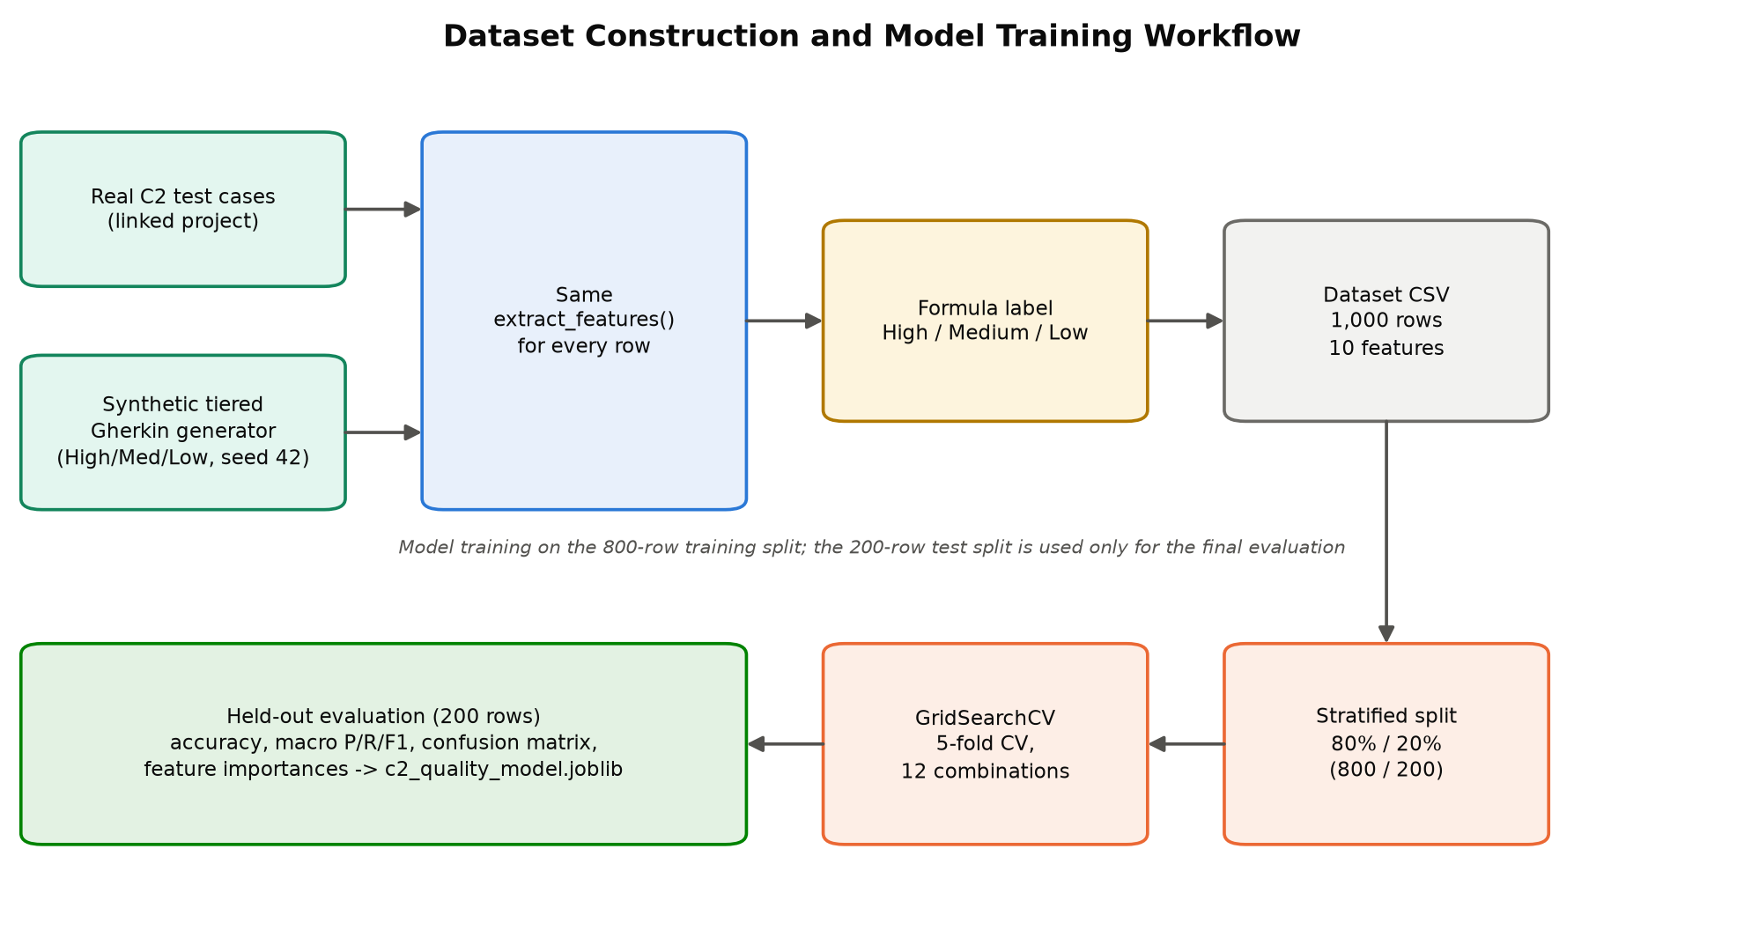
Figure 3.1: Dataset Construction and Model Training Workflow
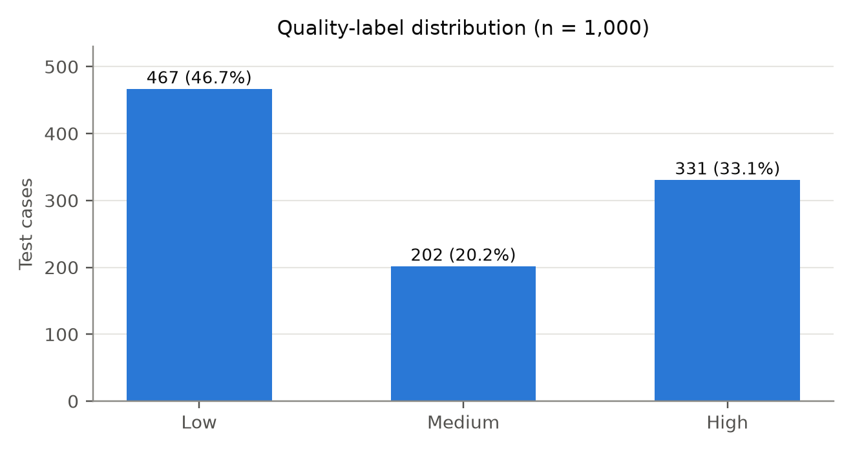
Figure 3.2: Quality-Label Distribution in the Dataset
For the functional and integration evaluation, the study materials were the live NextGen QA project data held by C1 and C2 at the time of testing, together with small, purpose-built fixtures (requirements, acceptance criteria, and test cases) that exercise each rule of the system. No human participants were involved in the evaluation reported in this thesis.

3.3 Experimental or study procedure
Model training and selection. The dataset is split into 800 training and 200 held-out test samples using a stratified 80/20 split, so that the held-out set (94 Low, 40 Medium, 66 High) is never used during tuning. A scikit-learn pipeline combines a StandardScaler with a RandomForestClassifier. Hyperparameters are tuned with GridSearchCV and five-fold cross-validation over n_estimators in {150, 300}, max_depth in {6, 10, None}, and min_samples_leaf in {2, 4}, a total of twelve configurations. The selected configuration was 150 trees, a maximum depth of 10, and a minimum of two samples per leaf. The fitted pipeline, its feature order, its label order, and a complete training report are serialised together with joblib.
Functional validation. Nine functional test cases (Section 5.4) were designed from the functional requirements, each with concrete inputs and expected outputs, and executed directly against the implemented modules and the trained model. Actual results were recorded as returned by the system.
Automated suite. A pytest suite of 73 automated test cases was executed in two modes: an offline mode that uses a temporary SQLite database and in-process fakes for C1 and C2, and a full mode that adds nine live end-to-end tests against the running RTM service, API gateway, C1, and C2. Each test records its objective, expected result, and the actual result captured at run time. Tests whose dependencies are unavailable are reported as Blocked rather than Passed.

3.4 Measures and evaluation metrics
The measures used in the evaluation are listed in Table 3.1.
Table 3.1: Evaluation Measures
Measure | Definition | Used for
Accuracy | Share of held-out test cases whose label is predicted correctly | RQ1, target ≥ 85%
Precision, recall, F1-score | Per class and macro-averaged over High, Medium, and Low | RQ1, Low-class precision target ≥ 90%
Cross-validated accuracy | Mean ± standard deviation over five folds of the training set | RQ1, stability
Formula agreement | Share of all rows where the model label equals the formula label | RQ1, fidelity
Robustness to execution status | Share of rows whose prediction is unchanged when test_result is flipped | RQ1, independence from pass/fail
Latency | Mean time to extract features and predict one test case | NFR1
Functional pass/fail | Actual result equals expected result for each test case | RQ2–RQ4
Risk factors and score | Five factors on a 0–100 scale and their mean | RQ3
Quality score change | Formula score and predicted label before and after improvement | RQ4

3.5 Data analysis
Model performance was analysed with a confusion matrix and per-class precision, recall, and F1-score on the held-out set. To understand what drives the model, Gini feature importances were extracted from the fitted forest and the Pearson correlation between each feature and the ordinal quality label (Low = 0, Medium = 1, High = 2) was computed over the full dataset. Independence from execution outcome was analysed in two ways: by the importance and correlation of the test_result feature, and by flipping test_result for every row and measuring how many predictions change. Functional and integration results were analysed by comparing actual with expected values, and the risk and improvement results were analysed factor by factor so that each outcome could be explained.

3.6 Ethics privacy security and responsible AI
Data and privacy. The model processes test-case text and project metadata only; no personal data is used for training or prediction. The training dataset is predominantly synthetic, and this is stated plainly in this thesis and in the model panel of the user interface rather than being concealed.
Transparency and human oversight. Predictions are always shown together with the explainable formula score and feature values, so that users can understand and contest a classification. TestQ-RTM applies the same quality criteria consistently to every test case, removing reviewer-to-reviewer variability, and is positioned as an assistant: it recommends improvements and generates candidate tests, but test cases enter the RTM or inventory only after an explicit user action. Test improvement is deterministic and does not use a large language model, which keeps it auditable.
Security. All traffic passes through the gateway, which enforces JWT authentication. Repository analysis is gated by an ownership or collaborator check, or by the project's stored token, and is rejected with HTTP 403 otherwise. Repositories are cloned into temporary directories, coverage jobs run under a per-project lock with a configurable timeout, credentials are read only from environment configuration, and coverage runners can be disabled entirely in constrained deployments.
Honest reporting. The automated test suite reports the real outcome of every test. Failing tests are reported as findings rather than suppressed, and tests that could not run are reported as Blocked.

3.7 Reproducibility and research artefacts
The research artefacts and the means to reproduce the results are listed in Table 3.2. Dataset generation is deterministic (random seed 42), the deployed model is stored with its full training report, and the reported held-out accuracy is re-computed from the saved model by an automated test (QP-13).
Table 3.2: Research Artefacts
Artefact | Location | Reproduction
TestQ-RTM backend service | RTM-and-Quality-Prediction-backend/app | uvicorn app.main:app --port 8003
Dataset builder and trainer | app/ml/c2_dataset.py, app/ml/c2_train.py | Seed 42; 80/20 stratified split; GridSearchCV
Trained model and training report | Serialised joblib bundle; GET /api/ml/c2-quality/model-info | Report exposed through the API
RTM frontend pages | frontend/src/pages/Rtm*.tsx | npm run dev (port 5173)
Automated research test suite | RTM-and-Quality-Prediction-backend/tests | pytest (full) or pytest -m "not live" (offline)
Test evidence report | tests/reports/latest.json and latest.md | Written on every run; shown on the Testing page

4 PRODUCT AND SOLUTION DESIGN

4.1 Requirements
Requirements were derived from the research problem, from discussions with the supervisors and the other component owners in the NextGen QA team, and from the data contracts exposed by C1 and C2. They were documented following the guidance of ISO/IEC/IEEE 29148 [26].
Functional requirements.
- FR1: Construct a live RTM linking requirements, user stories, acceptance criteria, test cases, and execution status for a selected project and iteration.
- FR2: Compute acceptance-criterion-level coverage and classify each requirement as Fully Covered, Partial, or Not Covered.
- FR3: Extract quality features from each test case and predict its quality score and High/Medium/Low label before execution.
- FR4: Expose the model's training report, including accuracy, confusion matrix, and feature importances, for transparency.
- FR5: Detect coverage gaps, compute an explainable risk score for each, and recommend an action.
- FR6: Generate a Given/When/Then test case for any uncovered acceptance criterion and allow it to be added to the RTM or test inventory.
- FR7: Analyse a low-quality test case, explain its gaps, rewrite it, and report the re-scored result.
- FR8: Classify the test portfolio into redundant, critical, and weak tests.
- FR9: Run statement and branch code-coverage analysis on the project's GitHub repository and report the results.
- FR10: Provide a dashboard, a unified test inventory, and PDF export of the RTM.
Non-functional requirements.
- NFR1: Quality predictions shall be produced in well under one second per test case so that pages can score entire projects on load.
- NFR2: The quality model shall achieve at least 85% accuracy on held-out data.
- NFR3: The RTM shall reflect the current state of C1 and C2 on every request, with no manual synchronisation.
- NFR4: The service shall degrade gracefully: if C2 is unreachable, the requirements side of the matrix shall still render.
- NFR5: Repository analysis shall be restricted to repositories the configured credentials are authorised to access.
- NFR6: The service shall expose a readiness probe that reports healthy only when its database is reachable.
Technical feasibility. TestQ-RTM is built on a mature, widely adopted stack. FastAPI provides an asynchronous web framework suited to concurrent calls to C1 and C2 [27]; SQLAlchemy provides object-relational mapping over PostgreSQL; scikit-learn provides the Random Forest implementation [15], [16]; and React with TypeScript provides the user interface. All machine learning runs locally on the CPU, so no GPU or paid inference API is required. Coverage measurement reuses standard, open-source tools (pytest-cov, Jest, nyc/Istanbul, and JaCoCo).
Operational feasibility. The service is independently deployable as a Docker container behind the NextGen QA API gateway, which routes the /api/rtm prefix to it. It can be started and stopped without affecting other components, and it tolerates the temporary unavailability of C2 by rendering the requirements side of the matrix with an empty test side. Economic feasibility is discussed in Section 8.3.

4.2 Component architecture within the complete solution
Figure 4.1 shows the overall NextGen QA architecture. All browser traffic passes through the API gateway, which verifies JSON Web Tokens issued by the authentication service and proxies requests to the four components. TestQ-RTM (C4) reads requirements, user stories, and acceptance criteria from C1 and Gherkin test cases with execution results from C2. It persists only the artefacts it creates itself, namely code-coverage reports and generated gap test cases, in its own PostgreSQL database, and it clones project repositories from GitHub when code coverage is requested.
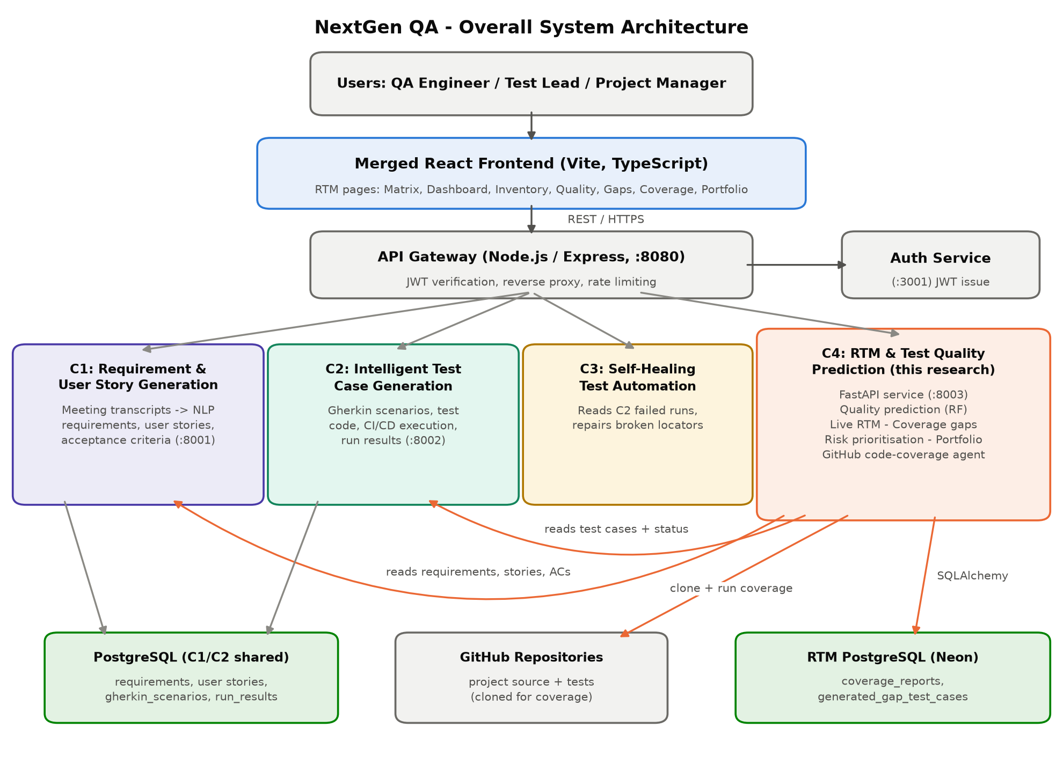
Figure 4.1: Overall NextGen QA System Architecture
Internally, the service follows the four-layer structure shown in Figure 4.2. The RTM pages in the presentation layer call the FastAPI routers of the API layer. The processing layer contains the RTM builder, feature extraction, the quality model, gap and risk scoring, test improvement, coverage runners, and portfolio analysis. The integration and data layer contains thin HTTP clients for C1 and C2, the GitHub client, the PostgreSQL session, the serialised model bundle, and the training dataset. A key design decision is that every endpoint is scoped by a (project_id, iteration_id) pair and that all pages derive their numbers from the same build_matrix() function, so the matrix, dashboard, inventory, and portfolio views always agree.
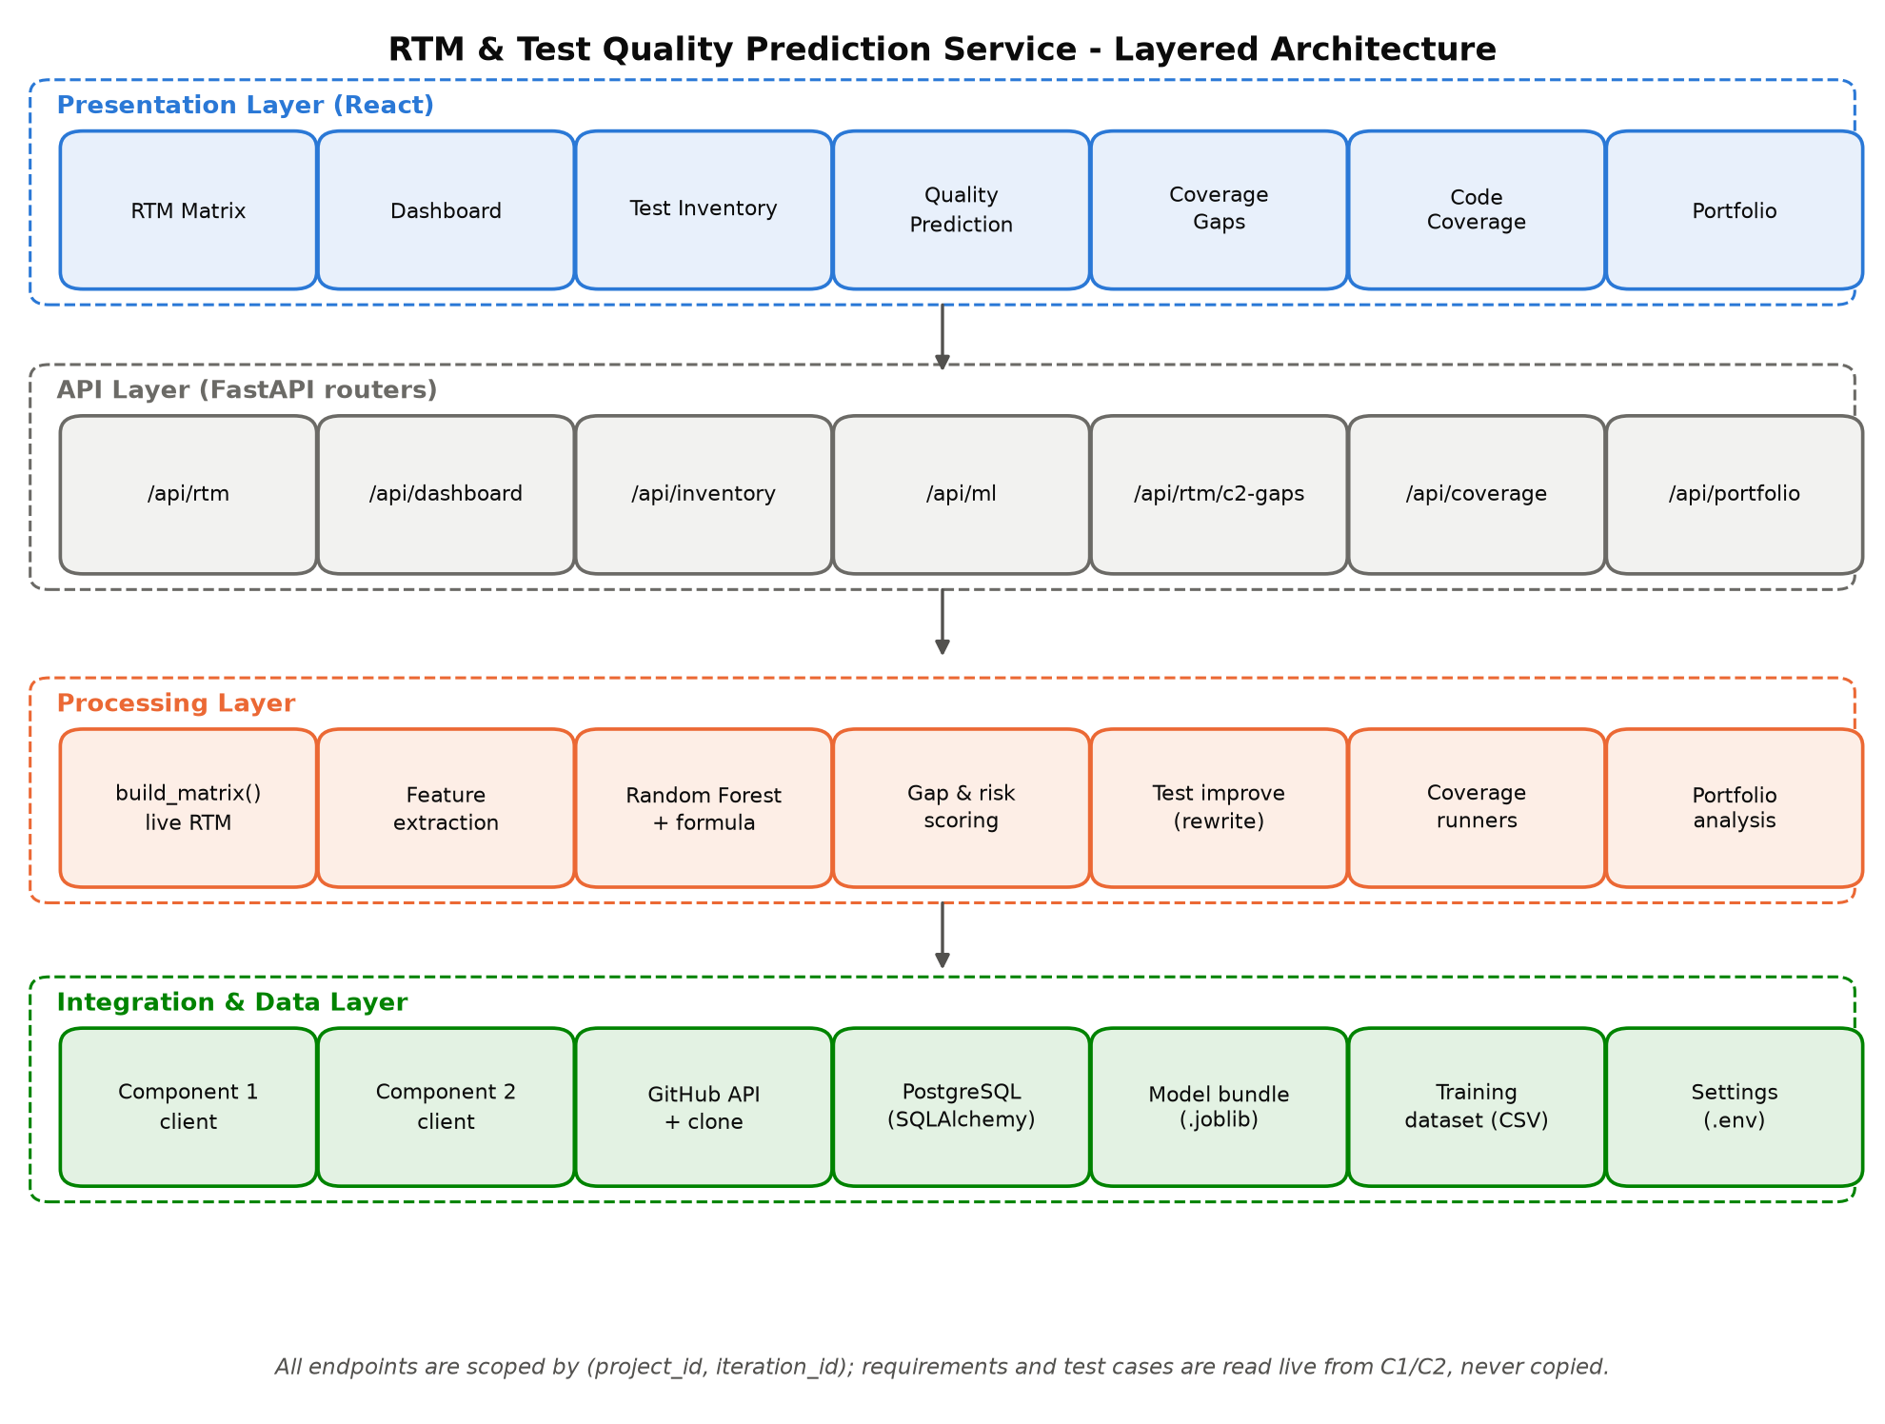
Figure 4.2: TestQ-RTM Layered Architecture

4.3 Design alternatives and decisions
The original proposal anticipated BERT-based semantic linking, a Neo4j graph store, and Jira integration. During implementation, it became clear that NextGen QA already provides explicit requirement-to-test links (C2 generates each test from a known user story) and a shared PostgreSQL ecosystem, so these elements were replaced with exact identifier joins, transparent word-overlap coverage at the acceptance-criterion level, and live API integration with C1 and C2. This kept the system explainable, fast, and free of external model dependencies. The principal decisions are summarised in Table 4.1.
Table 4.1: Design Alternatives and Decisions
Concern | Alternatives considered | Decision and rationale
Requirement–test linking | BERT/embedding similarity; manual links | Exact user-story identifier joins: links are explicit in C2, so inference would only add error
RTM storage | Neo4j graph; stored copy of C1/C2 data | Assemble live on every request: always consistent, nothing to synchronise
AC-level coverage | Sentence embeddings; manual tagging | 40% word overlap: transparent, fast, and consistent with the requirement_coverage feature
Quality classifier | Logistic regression, gradient boosting, neural text models | Random Forest: suits small tabular data, gives probabilities and importances
Quality label | Pass/fail outcome; manual labels | Weighted design-quality formula; pass/fail used only as a weak feature
Test improvement | Large language model rewrite | Deterministic, rule-based rewrite re-scored by the same model: auditable and offline
Issue tracker integration | Direct Jira integration | Use C1 as the requirement system of record within NextGen QA

4.4 Detailed design
Use cases. Figure 4.3 presents the use cases. Because the QA Engineer and the Project Manager or Test Lead share several use cases, both are modelled as specialisations of an abstract Platform User actor (actor generalisation, shown with hollow-headed arrows). The Platform User views the live RTM, exports it as a PDF, and reviews the risk-ranked coverage gaps; both specialised actors inherit these use cases, so each shared use case has a single association. In addition, the Project Manager or Test Lead consumes the quality dashboard and the portfolio view, while the QA Engineer views requirement trace details, browses the test inventory, predicts and improves test quality, generates tests for uncovered acceptance criteria and adds them to the RTM, and runs code-coverage analysis. Components 1 and 2 act as external systems that supply requirements and test cases, and GitHub supplies the repository for coverage analysis.
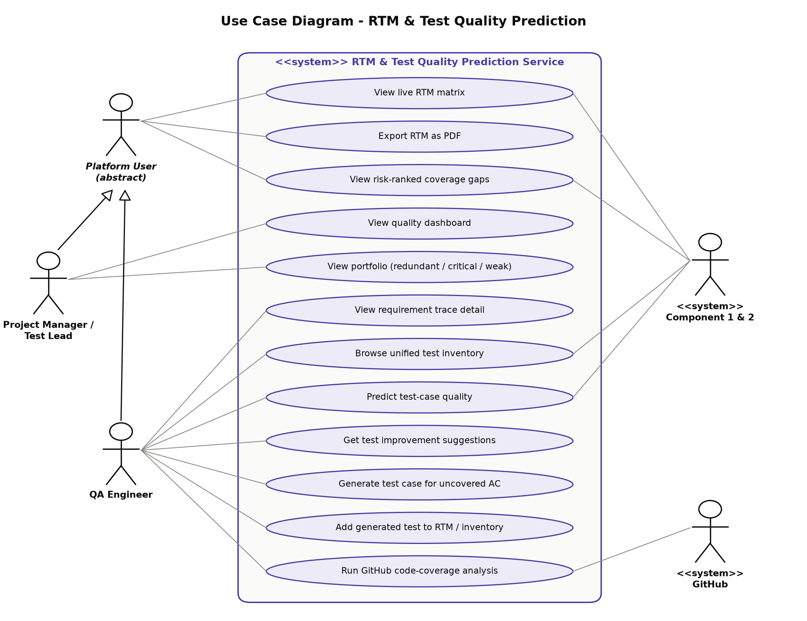
Figure 4.3: Use Case Diagram for TestQ-RTM
Interaction design. Figure 4.4 illustrates the interactions when a user opens the RTM Matrix page. The frontend calls the gateway, which forwards the request to TestQ-RTM. The service fetches the iteration's requirements with their user stories and acceptance criteria from C1, fetches the project's traceability test cases from C2, loads any generated gap test cases that have been added to the RTM, groups the tests by user story, computes coverage per acceptance criterion, derives a coverage status for each requirement, and returns the matrix with a summary. Activation bars show the period during which each participant is processing a request; the nested bar on the RTM service marks its internal build_matrix() call, and dashed arrows denote return messages.
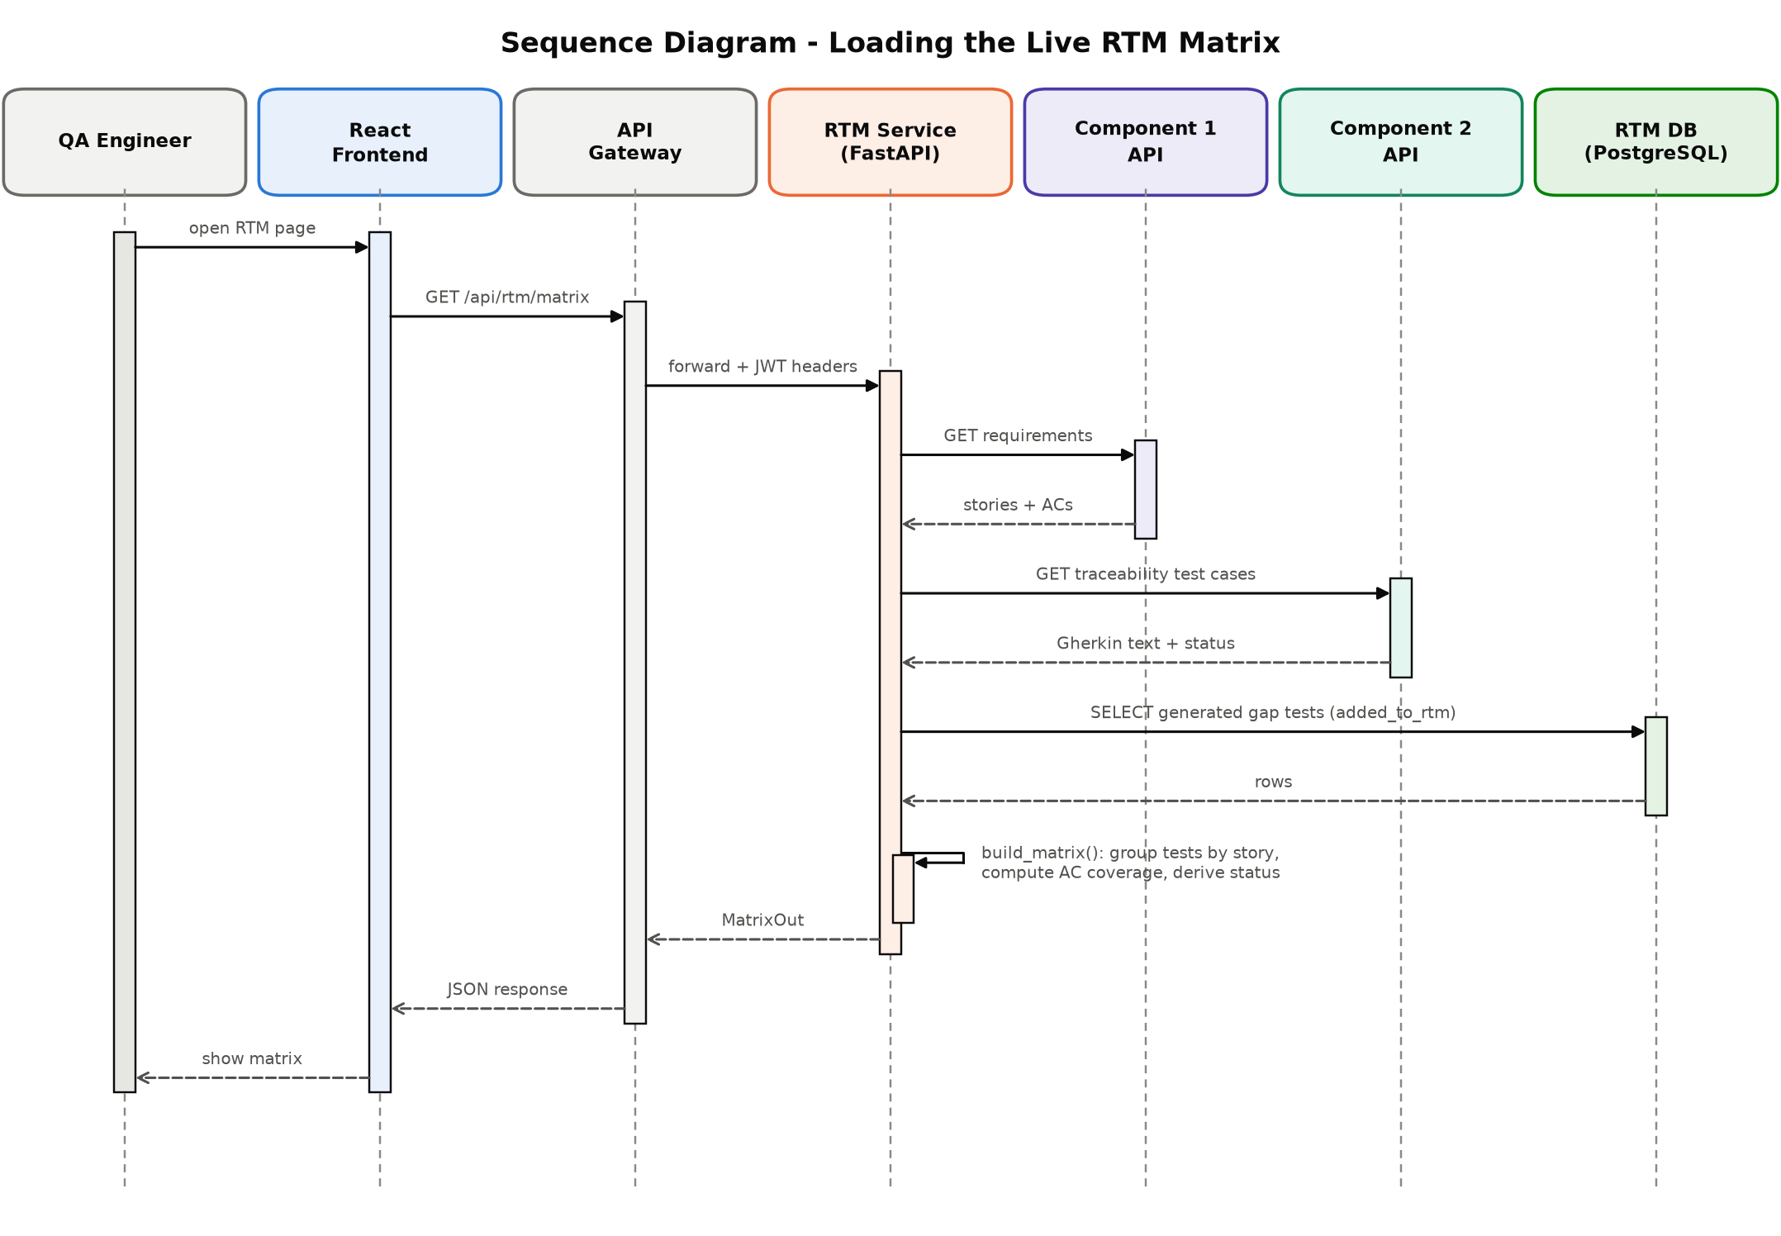
Figure 4.4: Sequence Diagram – Loading the Live RTM Matrix
Data model. Figure 4.5 summarises the data model. Requirements (owned by C1) and test cases (owned by C2) are joined live through the user story identifier, one requirement row to many test cases, and each MatrixRow is computed rather than stored. TestQ-RTM persists only two tables: coverage_reports, holding one row per project with its latest coverage run, and generated_gap_test_cases, holding test cases generated for uncovered acceptance criteria. A unique constraint on (project_id, requirement_id, acceptance_criterion) makes generation idempotent.
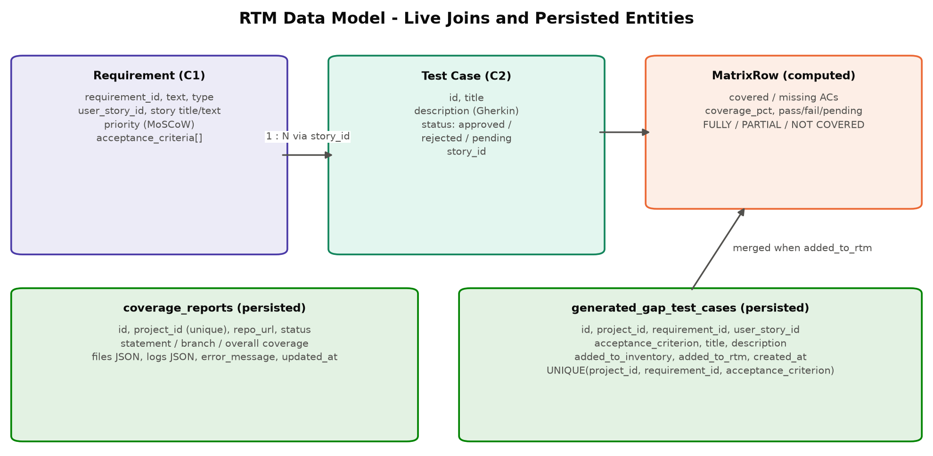
Figure 4.5: RTM Data Model – Live Joins and Persisted Entities
Test-case quality model. The extract_features() function converts one test case and its acceptance-criteria context into the ten features listed in Table 4.2. The same function is used to build the training dataset, to score live test cases, to score generated test cases, and to re-score improved test cases, which guarantees that training and inference operate on identical representations.
Table 4.2: Extracted Test-Case Quality Features
Feature | Type | Extraction rule
description_length | Integer | Number of characters in the Gherkin text
has_expected_result | Binary | 1 if a Then step is present
has_preconditions | Binary | 1 if a Given step or Background is present
has_test_steps | Binary | 1 if a When step is present
requirement_linked | Binary | 1 if the test's story has acceptance criteria in C1
requirement_coverage | 0–100 | Share of acceptance-criteria vocabulary that appears in the test text
ambiguity_score | 0–100 | Density of vague words (e.g. some, properly, appropriate), capped at 100
completeness_score | 0–100 | 25 each for Given, When, Then, plus up to 25 for scenario count (max 3)
specificity_score | 0–100 | Percentage of steps containing a quoted literal or a number
test_result | 0 / 0.5 / 1 | Failed, pending, or passed execution status

An explainable quality score on a 0–100 scale is computed from seven weighted factors, as shown in Equation (1). Binary indicators are scaled by 100, and ambiguity contributes inversely.
Q = 0.20·C + 0.20·R + 0.15·S + 15·E + 10·P + 10·T + 0.10·(100 − A) (1)
where C is completeness, R is requirement coverage, S is specificity, E, P, and T indicate the presence of an expected result, preconditions, and test steps, and A is the ambiguity score. The score is clipped to [0, 100] and mapped to a label: High when Q ≥ 80, Medium when 60 ≤ Q < 80, and Low when Q < 60. Execution outcome does not appear in Equation (1); this was an explicit design constraint, because a label derived from pass/fail would teach the model to predict execution success rather than design quality. The Random Forest described in Section 3.3 is trained on these labels, and both the formula score and the model's prediction are always displayed together, so that users see an interpretable value and the learned classification with its class probabilities. If no trained model is present, the service falls back to the formula label and reports the method as weighted_formula. Figure 4.6 shows the complete prediction pipeline.
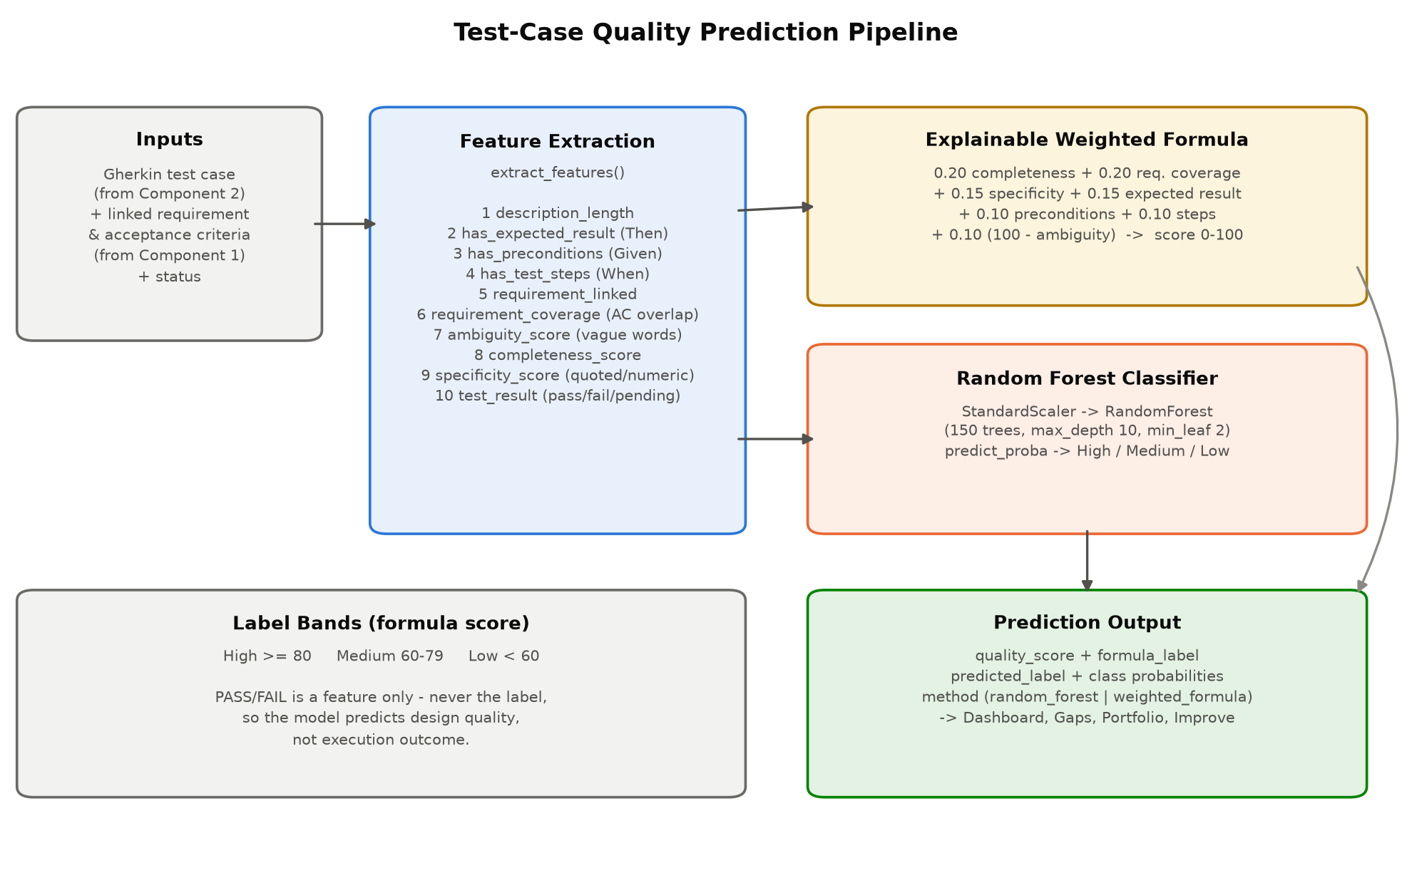
Figure 4.6: Test-Case Quality Prediction Pipeline
Acceptance-criterion-level coverage. An acceptance criterion is considered covered if at least 40% of its words of three or more letters appear in the Given/When/Then text of at least one linked test case. This is the same word-overlap notion that underlies the requirement_coverage feature, applied per criterion rather than across all criteria, so that the system uses a single, consistent definition of coverage throughout. The function returns the covered criteria, the missing criteria, and the coverage percentage for the requirement.
Coverage-gap detection and risk-based prioritisation. A requirement is reported as a gap if any of the following holds: it has no linked test case; at least one acceptance criterion is uncovered; a linked test case is failing; the average predicted quality of its linked tests is below 70; or all linked tests are still unexecuted. The last two conditions capture risks that text coverage alone would miss: a test may mention every acceptance-criterion word and still be poorly designed or never run. Each gap receives a risk score equal to the mean of five factors on a 0–100 scale, as shown in Equation (2) and Figure 4.7.
Risk = (F_priority + F_coverage + F_AC + F_failure + F_code) / 5 (2)
- Business priority maps the user story's MoSCoW priority to Must = 100, Should = 70, Could = 40, and Won't = 10 (50 if unknown).
- Coverage gap is 100 when no test is linked; otherwise it is a residual of 20 + 0.2 × (100 − coverage%).
- Acceptance-criteria gap is the percentage of criteria not covered.
- Test failure rate is the percentage of executed linked tests that failed; if none has been executed, it falls back to 100 minus the average predicted quality, and to 50 when no prediction is available.
- Code-coverage gap is 100 minus the project's overall code coverage from the latest analysis, or 50 if none has been run.
Scores of 70 or more are classed as Critical, 40 to 69 as Medium, and below 40 as Low. Gaps are sorted in descending order of risk and each is given a recommended action: generating a stated number of additional test cases, fixing failing tests, improving low-quality tests, executing unverified tests, or monitoring.
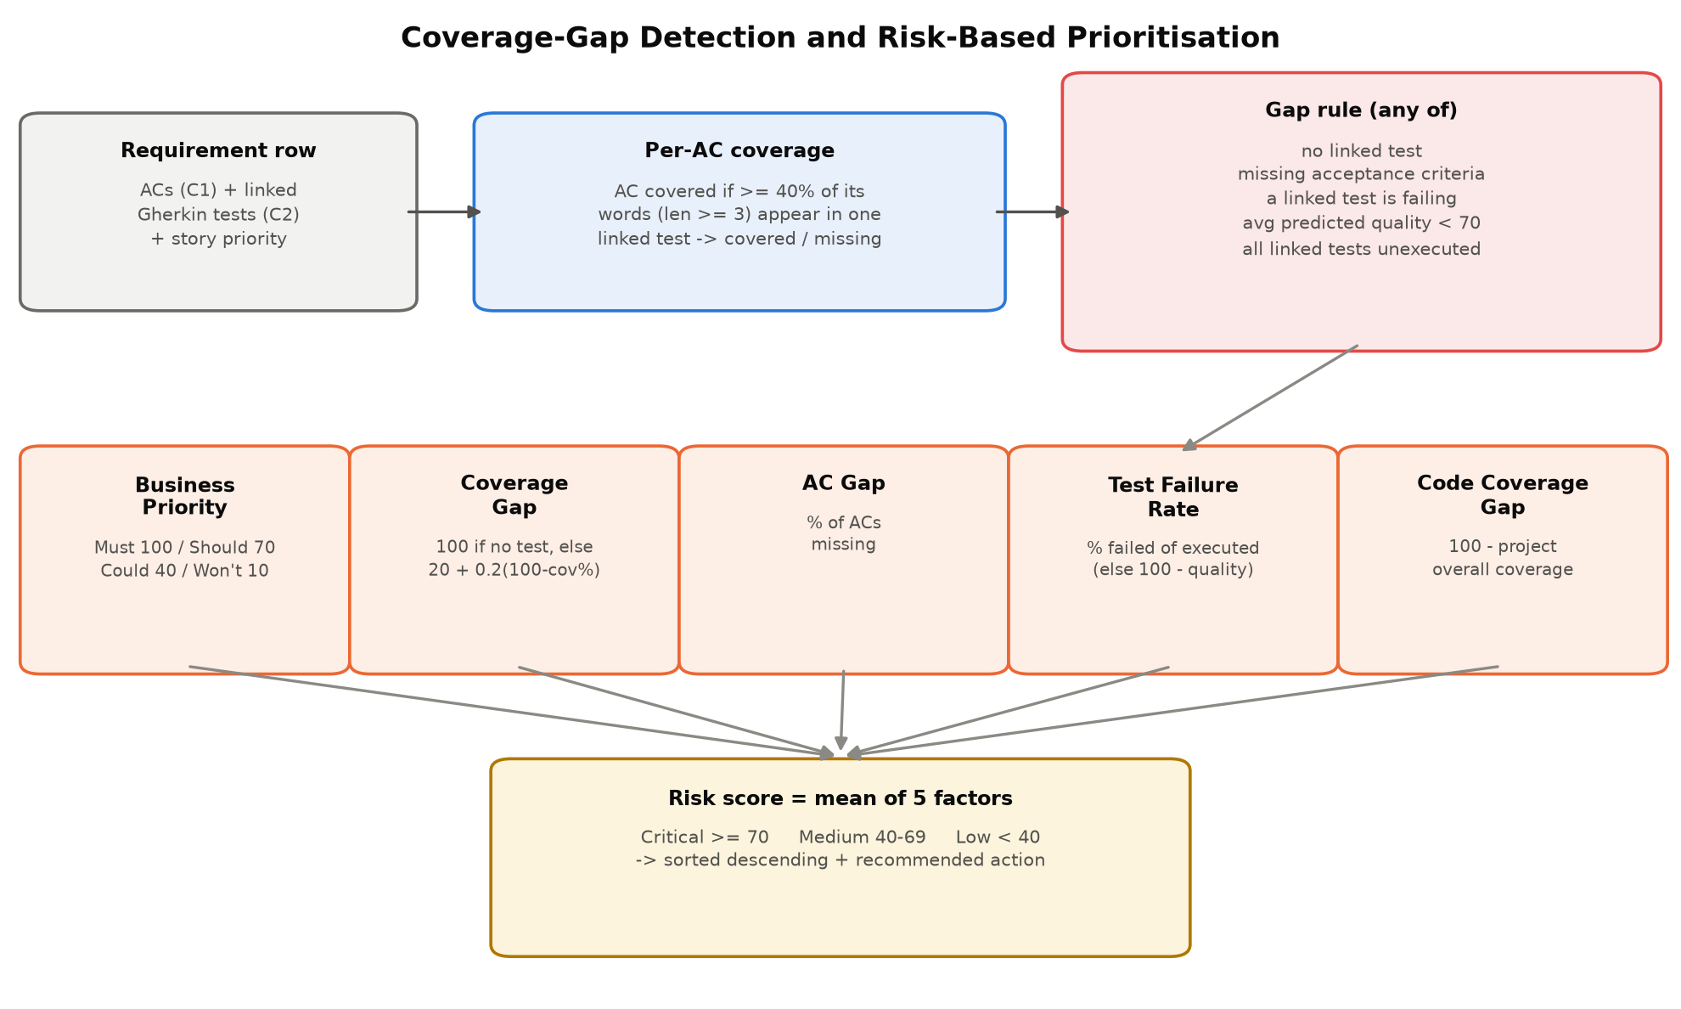
Figure 4.7: Coverage-Gap Detection and Risk-Based Prioritisation
Acceptance-criterion-specific test generation. For an uncovered criterion, generate_gap_test_case() produces a Gherkin scenario grounded in the criterion's own wording rather than a generic template. The persona is extracted from the user story's “As a …” clause; the criterion is split into an action and an outcome using conditional patterns (“If/When …, then …”) or capability patterns (“can”, “must”, “should”); and the requirement text is added as an additional precondition. The generated case is persisted idempotently, scored immediately with the quality model, and can be added to the RTM or test inventory with a single action. A bulk endpoint generates tests for all uncovered criteria of the critical gaps in one step.
Intelligent test improvement. As shown in Figure 4.8, analyze_gaps() checks eight conditions against the same features the model uses: missing preconditions, steps, or expected result; specificity below 50; ambiguity above 30; requirement coverage below 60; completeness below 70; and a missing requirement link. Each detected gap is reported with a plain-language status and a specific recommendation. generate_improved_gherkin() then rewrites the test as a complete feature with a happy-path scenario and an invalid-input scenario, concrete preconditions and expected results, and an explicit line that folds in the linked acceptance criteria. Crucially, the rewritten text is passed back through extract_features() and the model, so the reported improvement is a measured result rather than an asserted one.
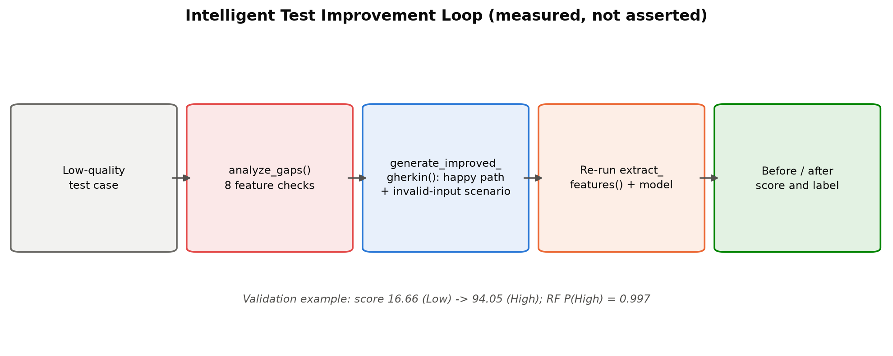
Figure 4.8: Intelligent Test Improvement Loop
Requirement-aware portfolio analysis. analyze_portfolio() classifies the live test set into three groups. Redundant tests are near-duplicates within the same user story, identified when the Jaccard similarity of their word sets is at least 0.8; these are candidates to merge or retire. Critical tests are those failing on a Must or Should requirement, or the only test covering such a requirement; these must be protected and prioritised. Weak tests are those the model labels Low or whose quality score is below 50; these are candidates for the improvement loop. Because the analysis is driven by the RTM, the system never suggests retiring the sole test of a high-priority requirement.
GitHub code-coverage agent. The coverage agent, shown in Figure 4.9, complements requirement-level coverage with code-level coverage. A request is accepted with HTTP 202 and executed in a background thread under a per-project lock. Access is granted only if the repository is the project's connected repository (using the personal access token stored by C2) or if the configured GitHub user is its owner or a collaborator. The repository is cloned into a temporary directory, and its root and first-level subdirectories are scanned for Python, JavaScript, and Java project markers, so that monorepos with separate client and server folders are analysed as multiple projects. The agent then runs pytest with pytest-cov, Jest or Mocha through nyc, or Maven/Gradle with JaCoCo (pinned to a supported LTS JDK, and without modifying the repository's build files). Results are merged by weighting each file's statement and branch percentages by its size, and overall coverage is defined uniformly as the mean of statement and branch coverage. Live log lines are stored with the report and polled by the frontend.
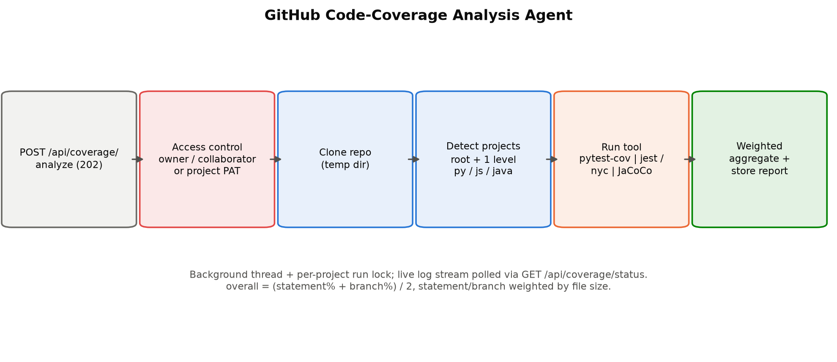
Figure 4.9: GitHub Code-Coverage Analysis Agent
User interface. The RTM pages present the results: the RTM Matrix with PDF export, a requirement detail view, a Dashboard with the quality distribution, average quality, code-coverage snapshot, and recent runs, a Test Inventory that scores every test live, the Quality Prediction page with model and dataset panels and the improvement action, the Coverage Gaps page with risk ranking and generation actions, the Code Coverage page, and the Portfolio page. A separate Testing page presents the evidence from the automated research test suite (Section 5.4). All pages share a context hook that holds the selected project and iteration.

4.5 Standards and professional practice
- Software testing: test-case structure and terminology follow ISO/IEC/IEEE 29119 [12]; every test case in the evaluation records an identifier, objective, input, expected result, actual result, and status.
- Requirements: functional and non-functional requirements were specified following ISO/IEC/IEEE 29148 [26].
- API design: the service exposes resource-oriented REST endpoints [28] with Pydantic-validated request and response schemas and an automatically generated OpenAPI description provided by FastAPI [27]; invalid input is rejected with HTTP 422 and upstream outages are reported with explicit status codes.
- Security: authentication is centralised in the gateway with JWTs, secrets are read only from environment variables and never committed, and repository access is authorised before any clone.
- Engineering practice: typed Python and TypeScript, a single configuration object, separation of routers, services, and integrations, deterministic model training, containerised deployment, and an automated test suite that reports failures honestly.
- Referencing: sources are cited in the IEEE style throughout this thesis.

5 IMPLEMENTATION INTEGRATION AND TESTING

5.1 Development environment and technology stack
Development was carried out on macOS (Apple Silicon) with Python 3.11 for the backend and Node.js with Vite for the frontend. The technology stack is summarised in Table 5.1.
Table 5.1: TestQ-RTM Technology Stack
Component | Technology | Purpose
Web framework | FastAPI 0.115 + Uvicorn | Asynchronous REST API
Persistence | PostgreSQL (Neon) + SQLAlchemy 2.0 | Coverage reports and generated gap test cases
Validation | Pydantic 2 + pydantic-settings | Request/response schemas and environment configuration
Machine learning | scikit-learn 1.5 (RandomForestClassifier, GridSearchCV) | Test-case quality classification
Data handling | pandas, NumPy, joblib | Dataset building, analysis, model serialisation
HTTP integration | httpx (async) | Live calls to Component 1, Component 2, and GitHub
Code coverage | pytest-cov, Jest, nyc/Istanbul, JaCoCo 0.8.12 | Statement and branch coverage per language
Frontend | React 19, TypeScript, Vite, Tailwind CSS, Recharts | RTM pages and dashboards
Export | jsPDF + jspdf-autotable | PDF export of the RTM
Testing | pytest 8.3 | Automated research test suite and evidence report
Deployment | Docker (python:3.12-slim), API gateway | Containerised service behind the gateway

5.2 Component implementation
Project structure. The backend is a Python package rooted at RTM-and-Quality-Prediction-backend/app (approximately 4,700 lines of Python). main.py creates the FastAPI application, configures CORS, creates tables on start-up, and exposes the health probe. routers/ contains one module per API area; services.py contains the RTM builder and portfolio analysis; ml/ contains feature extraction (c2_features.py), dataset construction (c2_dataset.py), training (c2_train.py), prediction (c2_predict.py), gap and risk analysis (c2_gap_analysis.py), and improvement (c2_improve.py); coverage/ contains the access control, cloning, language detection, and per-language coverage runners; integrations/ contains the C1 and C2 clients; and models.py, schemas.py, database.py, and config.py hold the ORM models, Pydantic schemas, session factory, and settings. The frontend RTM module consists of nine pages under frontend/src/pages/Rtm*.tsx (approximately 2,400 lines), shared components under components/rtm/, a typed API client (api/rtmApi.ts), and type definitions (types/rtm.ts).
Live RTM construction. The build_matrix() function is the single place where the RTM is assembled. For a given project and iteration, it fetches requirements with their user stories and acceptance criteria from C1, and traceability test cases from C2. Test cases are grouped by story_id and attached to the requirement row with the same user_story_id. Generated gap test cases that the user has added to the RTM are merged into the same rows with the source label “generated”. Each row's coverage status is Not Covered when it has no linked test, Partial when at least one acceptance criterion is not covered, and Fully Covered otherwise. A summary aggregates the number of requirements in each status, the number of passed, failed, and pending tests, the pass rate over executed tests, and the average coverage.
Feature extraction and prediction. The following excerpt from c2_features.py shows how structural and linguistic features are derived from Gherkin text.
has_expected_result = 1 if re.search(r"\bThen\b", text) else 0
has_preconditions = 1 if re.search(r"\b(Given|Background)\b", text) else 0
has_test_steps = 1 if re.search(r"\bWhen\b", text) else 0
steps = _step_lines(text)
specific_steps = sum(1 for line in steps if re.search(r'"[^"]+"|\d', line))
specificity_score = round((specific_steps / len(steps)) * 100, 1) if steps else 0.0
ambiguous_hits = sum(1 for w in words if w in _AMBIGUOUS_WORDS)
ambiguity_score = round(min(100.0, (ambiguous_hits / max(1, len(words))) * 1000), 1)
At inference time, predict_c2_quality() returns the formula score and label together with the Random Forest's predicted label and class probabilities:
row = [[features[key] for key in order]]
proba = pipeline.predict_proba(row)[0]
model_classes = list(pipeline.named_steps["model"].classes_)
probabilities = {cls: float(proba[i]) for i, cls in enumerate(model_classes)}
predicted_label = model_classes[int(proba.argmax())]
REST API. The service exposes the endpoints summarised in Table 5.2. All project-scoped endpoints accept project_id and iteration_id query parameters, and all are reached through the gateway's /api/rtm route in the integrated deployment.
Table 5.2: TestQ-RTM REST API Endpoint Summary
Method | Endpoint | Description
GET | /api/health | Readiness probe; healthy only if the database is reachable
GET | /api/rtm/matrix | Live RTM with summary and per-requirement rows
GET | /api/rtm/matrix/requirements/{id} | Trace detail for one requirement
GET | /api/dashboard/summary | Matrix summary, quality distribution, coverage snapshot, recent runs
GET | /api/inventory | Unified test inventory with live quality scores
GET | /api/ml/c2-quality/model-info | Training report of the deployed model
GET | /api/ml/c2-quality/dataset-info | Dataset statistics and feature correlations
GET | /api/ml/c2-quality/predictions/{project_id} | Quality predictions for all project test cases
POST | /api/ml/c2-quality/improve | Gap analysis, rewrite, and re-scored result
GET | /api/rtm/c2-gaps | Risk-ranked coverage gaps
POST | /api/rtm/c2-gaps/generate-test-case | Generate and score a test for one uncovered criterion
POST | /api/rtm/c2-gaps/generate-all | Bulk generation for critical gaps
POST | /api/rtm/c2-gaps/{id}/add | Add a generated test to the RTM or inventory
POST | /api/coverage/analyze | Start GitHub code-coverage analysis (HTTP 202)
GET | /api/coverage/status | /report | Live log stream and final coverage report
GET | /api/portfolio/analysis | Redundant, critical, and weak tests
GET | /api/external/component1|2/… | Read-only proxies to C1 and C2 data
GET/POST/PUT | /api/testing/report | /run | /manual/{id} | Test evidence report, on-demand test runs, manual check results

5.3 Integration with the other components
Component 1. A thin asynchronous client calls C1's requirements-with-stories endpoint for the selected iteration and maps each requirement, its user story, MoSCoW priority, and acceptance criteria into an RTM row. If C1 is unreachable, the RTM endpoints return HTTP 503 with a clear message, because no matrix can be built without requirements.
Component 2. A second client reads the project's traceability test cases, test suites, and execution results. Execution status is derived without any foreign key from execution results back to scenarios. For each Gherkin scenario, the service locates the active test suites whose source scenario identifiers include it, takes only the latest execution of each suite, and matches the execution's scenario names against the scenario titles in the Gherkin text using word overlap (at least 50% of title words). A test is marked failed (“rejected”) if any matched result failed, passed (“approved”) if all matched results passed, and pending if nothing matched. Using only active suites and only the latest execution prevents a since-fixed test from being reported as failing. If C2 is unreachable, the requirements side of the matrix still renders with an empty test side (NFR4). The repository personal access token stored by C2 is used, through an internal key, to authorise coverage analysis of the project's connected repository.
API gateway and frontend. In the integrated deployment, the API gateway routes the /api/rtm prefix to the service through its RTM_SERVICE_URL setting, strips the prefix, and enforces JWT authentication. The RTM pages are part of the shared NextGen QA frontend and use a single typed API client; an automated contract test (API-02) verifies that every frontend call resolves to an existing backend route.

5.4 Verification and software testing
Test plan and strategy. Testing was conducted at three levels: unit-level validation of the feature extraction, scoring, coverage, risk, generation, improvement, portfolio, and coverage-aggregation functions; integration testing of the API endpoints against running instances of C1 and C2; and evaluation of the model on held-out data. The test strategy comprised the following steps:
- Define the items to be tested from the functional requirements.
- Select functions according to their importance and risk to the user.
- Design test cases with concrete inputs and expected outputs.
- Execute the test cases against the implemented modules and record the actual results.
- Identify defects, correct them, and repeat until the expected results are met.
Functional test cases. The following test cases were executed directly against the implemented backend modules and the trained model; the actual results reported are the values returned by the system.
Table 5.3: Test Case – Quality Prediction for a Well-Designed Test Case
Test Case ID | TC-01
Test Case | Quality prediction for a complete, specific test case
Test Scenario | Verify that a test case with full Given/When/Then structure, quoted values, and acceptance-criteria vocabulary is classified as High quality
Input | Two-scenario “User Login” feature with quoted credentials and status code 200; two linked acceptance criteria; status approved
Expected Output | 1. Completeness, specificity, and coverage features are high  2. Ambiguity is 0  3. Label = High
Actual Result | 1. Completeness 91.7, specificity 100.0, requirement coverage 78.9  2. Ambiguity 0.0  3. Formula score 94.12 (High); Random Forest High with P(High) = 0.902
Status | Pass

Table 5.4: Test Case – Quality Prediction for a Deficient Test Case
Test Case ID | TC-02
Test Case | Quality prediction for a vague, incomplete test case
Test Scenario | Verify that a test case with no Given or Then step and vague wording is classified as Low quality
Input | “When some action is performed properly on the login”; no linked acceptance criteria; status pending
Expected Output | 1. Missing preconditions and expected result detected  2. High ambiguity  3. Label = Low
Actual Result | 1. has_preconditions = 0, has_expected_result = 0  2. Ambiguity 100.0, specificity 0.0  3. Formula score 16.66 (Low); Random Forest Low with P(Low) = 1.00
Status | Pass

Table 5.5: Test Case – Independence of Quality from Execution Outcome
Test Case ID | TC-03
Test Case | Pass/fail must not determine quality
Test Scenario | Verify that changing only the execution status of a well-designed test does not change its quality classification
Input | TC-01 features with test_result = 1.0 (passed) versus 0.0 (failed)
Expected Output | Same formula score and same predicted label
Actual Result | Formula score 94.12 in both cases; label High in both cases; P(High) changed only from 0.902 to 0.893
Status | Pass

Table 5.6: Test Case – Acceptance-Criterion-Level Coverage
Test Case ID | TC-04
Test Case | Partial coverage detection
Test Scenario | Verify that a criterion not addressed by any linked test is reported as missing
Input | Three acceptance criteria (valid login, wrong-password error, account lockout after five failures) and the TC-01 test text
Expected Output | Two criteria covered, lockout criterion missing, coverage 66.7%, status Partial
Actual Result | Covered: valid login and wrong-password error; Missing: “The account is locked after five failed login attempts”; coverage 66.7%
Status | Pass

Table 5.7: Test Case – Risk Scoring of an Untested Must Requirement
Test Case ID | TC-05
Test Case | Risk prioritisation
Test Scenario | Verify that an untested high-priority requirement is classified as Critical with an actionable recommendation
Input | Priority Must, three acceptance criteria all missing, no linked tests, project code coverage 62.5%
Expected Output | Risk level Critical (score ≥ 70); recommendation to generate three test cases
Actual Result | Factors: priority 100, coverage gap 100, AC gap 100, failure rate 50 (no data), code-coverage gap 37.5; risk score 77.5 (Critical); action “Generate 3 additional test cases for this requirement.”
Status | Pass

Table 5.8: Test Case – Test Generation for an Uncovered Acceptance Criterion
Test Case ID | TC-06
Test Case | Gap test-case generation
Test Scenario | Verify that a generated test case is grounded in the uncovered criterion and is scored immediately
Input | Criterion “The account is locked after five failed login attempts”; story “User Login”; requirement text on account locking
Expected Output | Gherkin scenario with Given/When/Then whose text covers the criterion; quality prediction returned
Actual Result | Scenario generated with Given, And (requirement), When, Then, and And steps; requirement coverage 100.0; formula score 84.66 (High); Random Forest Medium with P(Medium) = 0.534 due to low specificity (20.0)
Status | Pass

Table 5.9: Test Case – Intelligent Improvement of a Low-Quality Test
Test Case ID | TC-07
Test Case | Measured test improvement
Test Scenario | Verify that gaps are explained and that the rewritten test is re-scored through the model
Input | TC-02 test case with its features; two linked acceptance criteria
Expected Output | Gaps listed with recommendations; rewritten test scores higher than the original
Actual Result | Seven gaps reported (preconditions, expected result, specificity, clarity, requirement coverage, completeness, requirement link); score improved from 16.66 (Low) to 94.05 (High); Random Forest P(High) = 0.997
Status | Pass

Table 5.10: Test Case – Portfolio Classification
Test Case ID | TC-08
Test Case | Redundant, critical, and weak test detection
Test Scenario | Verify that the portfolio analysis identifies each category correctly
Input | Must requirement with two identical tests (A, B); Must requirement with a single test (C); Should requirement with a failing test (D) and a vague test (E)
Expected Output | Redundant: B; Critical: C and D; Weak: E
Actual Result | Redundant: B (“Nearly identical to Login A”); Critical: C (only test on a Must requirement) and D (failing on a Should requirement); Weak: E (rated Low, 20/100)
Status | Pass

Table 5.11: Test Case – Weighted Code-Coverage Aggregation
Test Case ID | TC-09
Test Case | Size-weighted coverage merging
Test Scenario | Verify that a small, poorly covered file does not dilute a large, well-covered file
Input | a.py: 200 statements at 90%, 40 branches at 75%; b.py: 20 statements at 10%, 10 branches at 0%
Expected Output | Weighted statement 82.73%, branch 60.0%, overall 71.37% (simple averages would give 50.0% and 37.5%)
Actual Result | Statement 82.73%, branch 60.0%, overall 71.37%
Status | Pass

Automated research test suite. To make verification repeatable, the functional checks were extended into an automated pytest suite of 73 test cases in six modules, together with seven manually verified user-interface checks. A pytest plugin records, for each test, its identifier, module, objective, expected result, the actual result captured at run time, and its status (Passed, Failed, Blocked, or Not executed). The resulting evidence report is written to tests/reports/latest.json and is presented on the RTM Testing page, where the suite can also be run on demand. Offline tests use a temporary SQLite database and in-process fakes for C1 and C2, so they never modify the shared database or the other components. Table 5.12 summarises the coverage of the suite and the results of the full run on 10 October 2026 (Python 3.11.15, pytest 8.3.3), which took 133.9 seconds.
Table 5.12: Automated Research Test Suite – Results of the Full Run
Module | IDs | What is verified | Total | Passed | Failed
Quality Prediction | QP-01 – QP-15 | Feature extraction, weighted formula, label bands, pass/fail independence, held-out accuracy reproduced from the saved model | 15 | 15 | 0
RTM Generation | RTM-01 – RTM-12 | C1 fields carried into rows, linking by story, coverage status, pass/fail derived from C2 executions | 12 | 12 | 0
Coverage Gap Detection | GAP-01 – GAP-14 | 40% AC-overlap rule, gap conditions, risk formula and bands, grounded and idempotent generation | 14 | 14 | 0
Intelligent Test Improvement | IMP-01 – IMP-09 | Gap identification, generated structure, re-scoring, preservation of original content | 9 | 7 | 2
API & Integration | API-01 – API-14 | Health probe, frontend–backend contract, outages of C1/C2, validation errors, endpoint consistency | 14 | 14 | 0
Live Integration | LIVE-01 – LIVE-09 | Running services, C1 and C2 contracts, live RTM equals C1 and C2 data, dashboard equals matrix | 9 | 9 | 0
Total |  |  | 73 | 71 | 2

No test was Blocked or Not executed in this run. The two failures are genuine findings about the current implementation and were deliberately not hidden; they are analysed in Section 6.2. The user interface itself is verified manually because the frontend project does not include a browser-automation framework; the frontend–backend contract is nevertheless checked automatically by API-02.

5.5 Deployment and operation
The service is packaged as a python:3.12-slim Docker image that exposes port 8003 and defines a container health check against /health. In the integrated deployment, the API gateway (port 8081) routes the /api/rtm prefix to the service through the RTM_SERVICE_URL setting, alongside the authentication service (port 3001), C1 (port 8001), C2 (port 8002), and the frontend (port 5173). Configuration (database URL, C1 and C2 base URLs, GitHub credentials, the internal key for C2, and the coverage flag) is read from environment variables through a single settings object (Appendix A). Code-coverage runners can be disabled through a configuration flag in deployments that do not ship the build toolchains. The tests/ folder is not copied into the Docker image, so the testing dashboard reports the suite as unavailable in that deployment and the suite is run from a source checkout.

6 RESULTS AND VALIDATION

6.1 Research results
Evaluation setup. The quality model was evaluated on the 1,000-row dataset described in Section 3.2, using the stratified split and tuning procedure of Section 3.3. Timing measurements were taken on a developer laptop (Apple Silicon, Python 3.11). Table 6.1 summarises the results.
Table 6.1: Quality Model Performance Summary
Metric | Result
Cross-validated accuracy (5-fold, training set) | 98.38% ± 1.02%
Held-out accuracy (n = 200) | 98.0%
Macro precision / recall / F1-score | 0.970 / 0.986 / 0.977
Low class: precision / recall / F1 | 1.000 / 0.957 / 0.978
Medium class: precision / recall / F1 | 0.909 / 1.000 / 0.952
High class: precision / recall / F1 | 1.000 / 1.000 / 1.000
Agreement with formula label (all 1,000 rows) | 99.4%
Predictions unchanged when test_result is flipped (QP-12) | 99.8% of 1,000 rows
Held-out accuracy re-computed from the saved model (QP-13) | 0.9800 (matches stored metadata)
Mean prediction latency (incl. data conversion) | ≈ 2.9 ms per test case
Mean feature-extraction latency | ≈ 0.05 ms per test case

Classification performance. The tuned Random Forest correctly classified 196 of the 200 held-out test cases. As the confusion matrix in Figure 6.1 shows, all errors were Low-quality test cases predicted as Medium; no High test case was misclassified, and no Low test case was predicted as High. For the intended use, which is filtering and flagging weak tests, this error pattern is acceptable: when the model labels a test Low, it was correct in every case (precision 1.00), comfortably exceeding the target of 90% precision for low-quality rejection. The per-class results are shown in Figure 6.2.
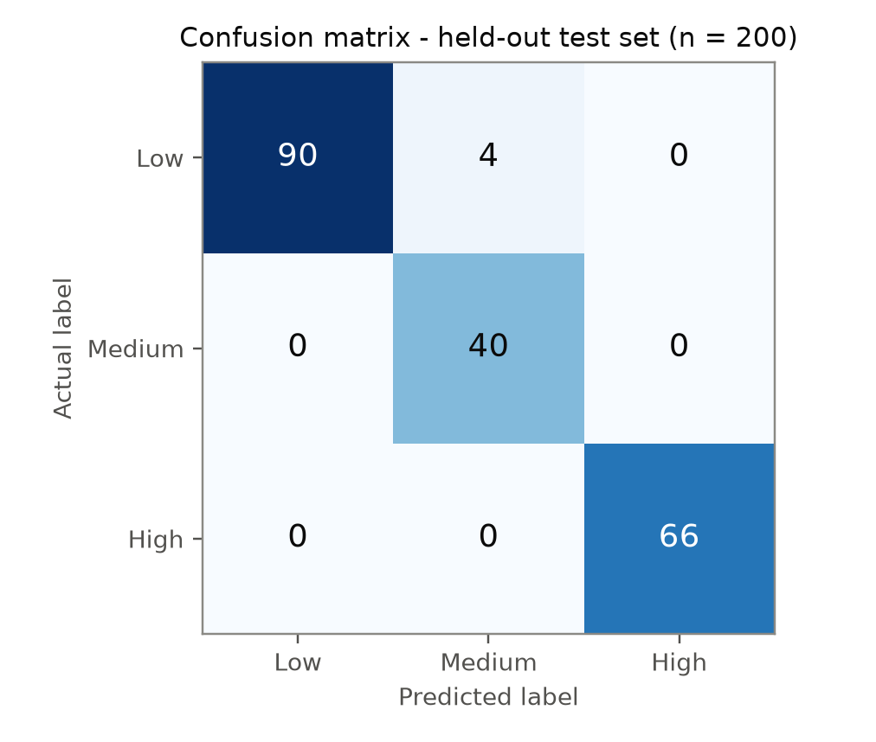
Figure 6.1: Confusion Matrix on the Held-Out Test Set
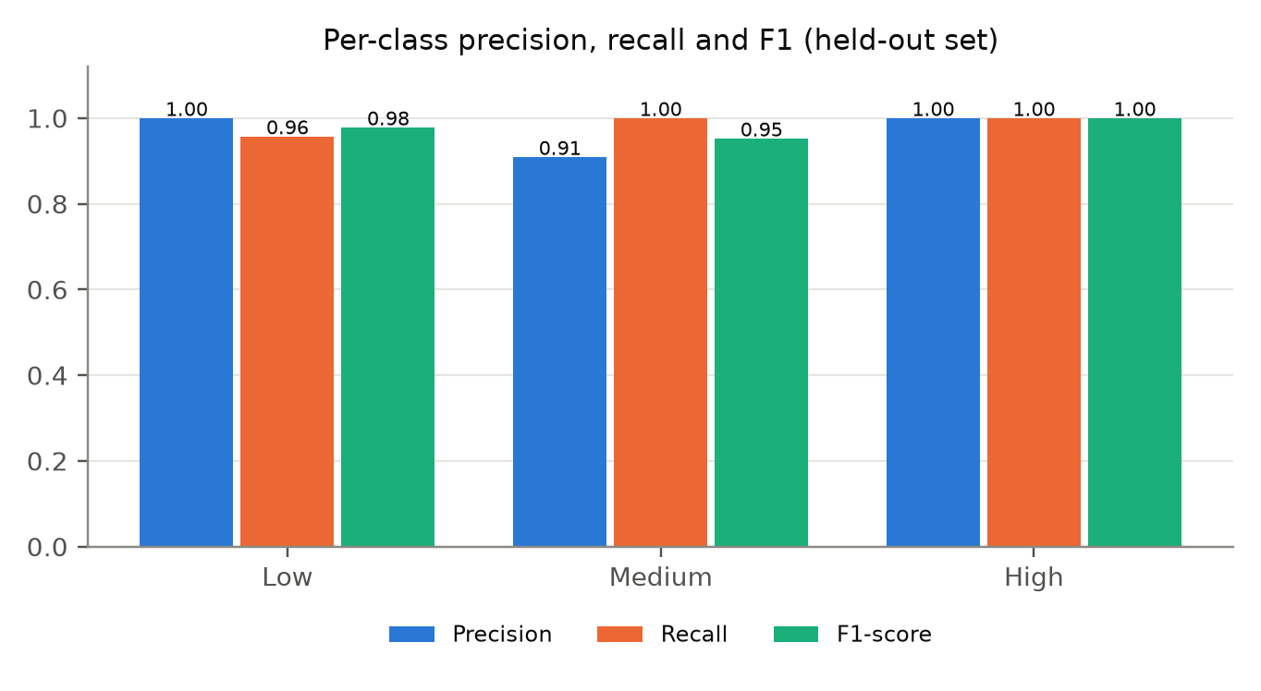
Figure 6.2: Per-Class Precision, Recall, and F1-Score
Feature importance and correlation analysis. Figure 6.3 shows the Gini importances of the deployed model. Requirement coverage (0.267), description length (0.212), and completeness (0.175) are the strongest predictors, followed by specificity (0.130) and ambiguity (0.100). Execution outcome has the lowest importance of all features (0.002), and its correlation with the label is only 0.086 (Figure 6.4), which confirms that the model does not use pass/fail as a proxy for quality. This is corroborated by QP-12: flipping the execution status of every row left 99.8% of predictions unchanged. Ambiguity is the only feature negatively correlated with quality (−0.564), as expected.
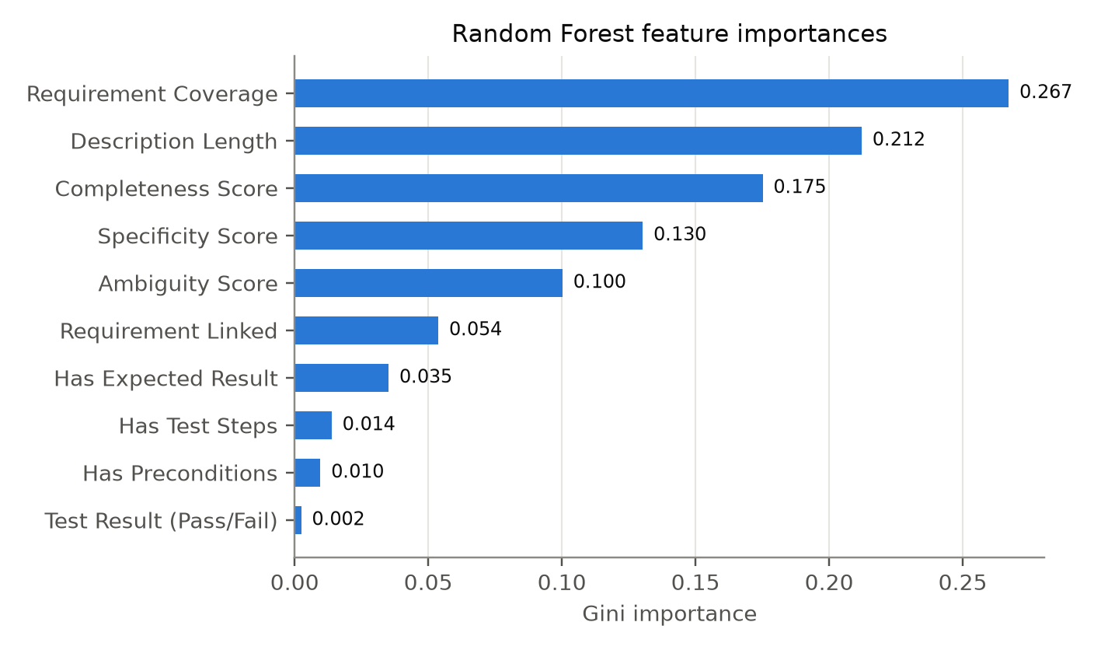
Figure 6.3: Random Forest Feature Importances
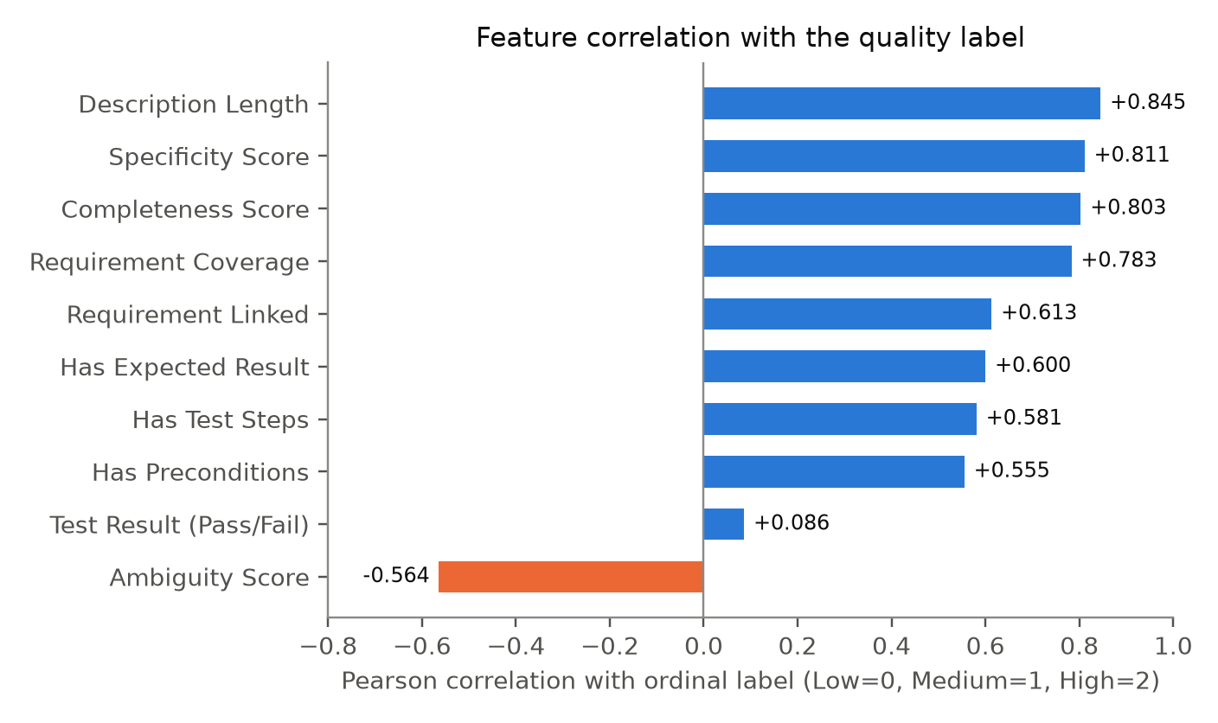
Figure 6.4: Correlation of Each Feature with the Quality Label

6.2 Product and technical results
Risk prioritisation. Figure 6.5 shows the factor breakdown for three representative requirements. An untested Must requirement scored 77.5 and was classified Critical, driven by maximal priority, coverage-gap, and acceptance-criteria-gap factors. A partly covered Should requirement with a passing test scored 33.5 (Low), and a fully covered Could requirement scored 15.0 (Low). Because each factor is reported individually, a reviewer can see precisely why a gap was ranked where it was.
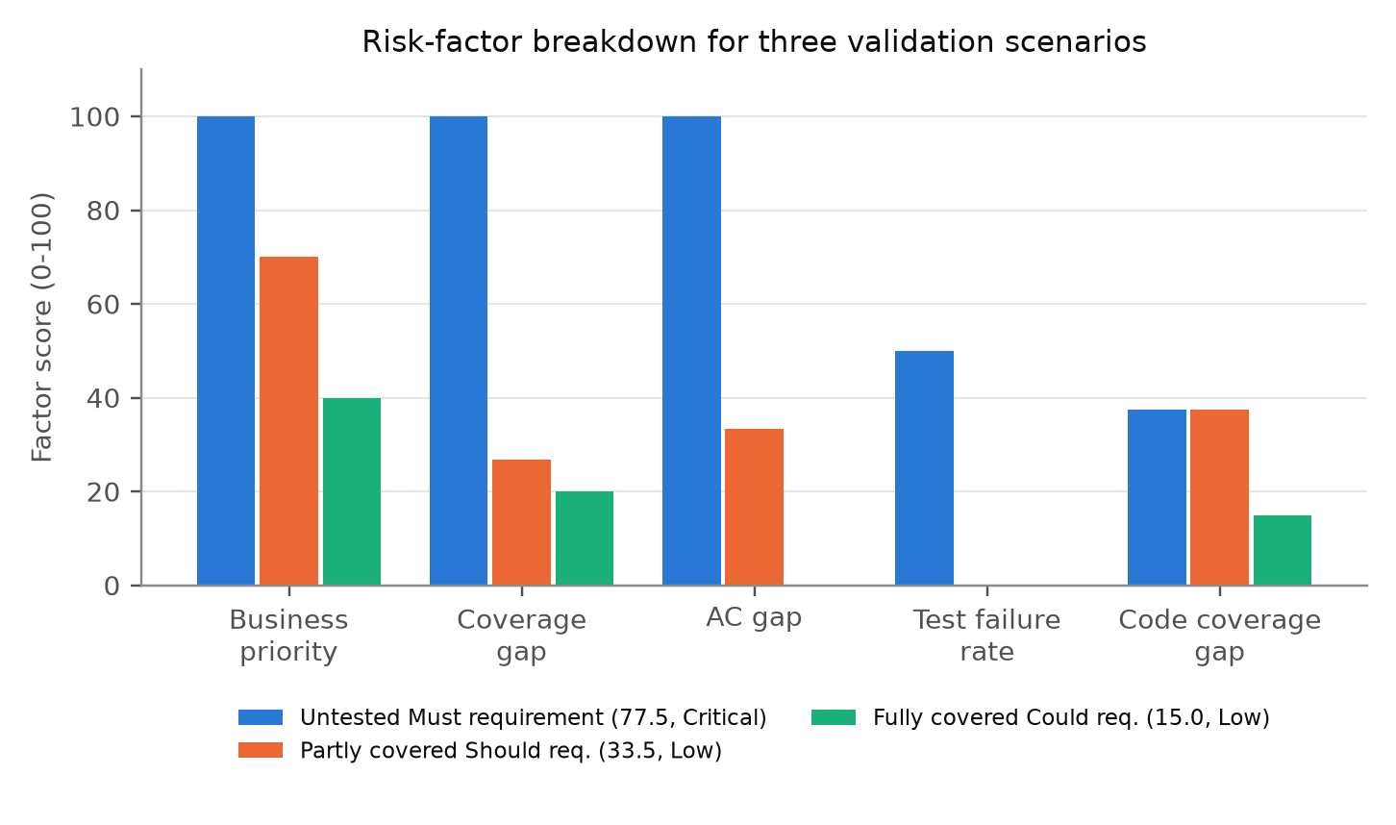
Figure 6.5: Risk-Factor Breakdown for Three Validation Scenarios
Test improvement. Figure 6.6 presents the measured effect of the improvement loop on the deficient test case from TC-02. Completeness rose from 33.3 to 91.7, specificity from 0.0 to 71.4, requirement coverage from 0.0 to 100.0, and ambiguity fell from 100.0 to 0.0, raising the quality score from 16.66 to 94.05 and the predicted label from Low to High with a probability of 0.997.
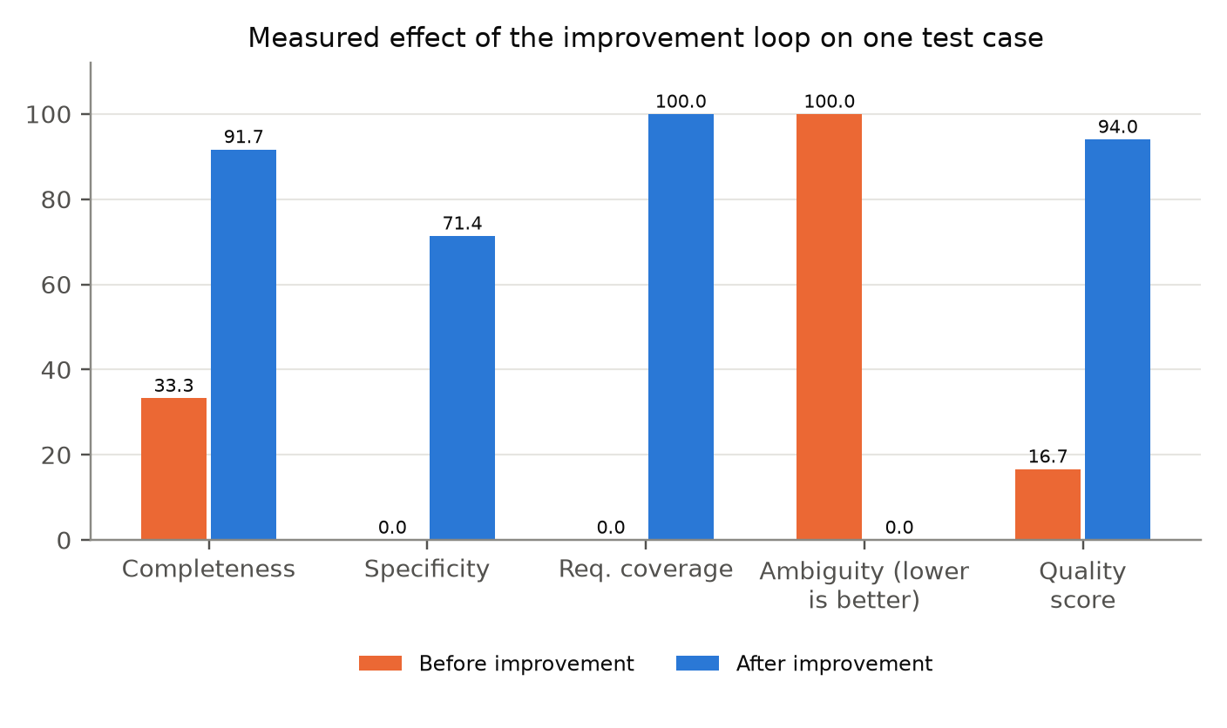
Figure 6.6: Measured Effect of the Improvement Loop
Findings from the automated test suite. The automated suite exposed two limitations of the improvement step that the functional test cases had not revealed. In IMP-04, none of the six original steps of a test case was preserved in the improved text: generate_improved_gherkin() rebuilds the scenario from a template using only the title, story title, and acceptance criteria, and never reads the original description, so concrete values are replaced rather than extended. In IMP-07, improving an already complete test lowered its score slightly, from 94.12 to 94.05 (both High), because specific quoted values were replaced with generic wording (specificity fell from 100.0 to 71.4). Both results show that the improvement is valuable for deficient tests but should preserve existing content and should not be applied to tests that are already of high quality.
The suite also documented two behaviours that are correct by design but should be understood by users: a requirement with no acceptance criteria and at least one linked test is reported as Fully Covered because there is nothing further to check (RTM-07), and C2 test cases whose story is not part of the selected C1 iteration are not shown in that iteration's RTM (RTM-03).
Performance. Feature extraction took about 0.05 ms and a full prediction about 2.9 ms per test case, so a project with several hundred test cases can be scored in under a second, satisfying NFR1. The offline test suite completes in about three seconds, which makes it practical to run on every change.

6.3 User or stakeholder validation
A formal evaluation with QA practitioners was planned (the budget in Section 8.3 includes participant incentives), but it had not been conducted at the time of writing, and no user-study results are therefore reported. As a first step towards stakeholder validation, seven manual user-interface checks were defined and are recorded on the Testing page, separately from the automated results (Table 6.2). At the time of writing, no outcome had been recorded for any of them, so all seven are reported as Not verified. The components and their outputs were reviewed with the supervisors and the other component owners during development.
Table 6.2: Manual User-Interface Checks
ID | Check | Status
MAN-01 | RTM Matrix page shows live requirements and coverage | Not verified
MAN-02 | RTM export to PDF | Not verified
MAN-03 | Quality Prediction page shows score, label and probabilities | Not verified
MAN-04 | Improve action shows gaps and before/after scores | Not verified
MAN-05 | Coverage Gaps page ranks gaps and generates a test | Not verified
MAN-06 | Clear error when Component 1 is stopped | Not verified
MAN-07 | Dashboard and Portfolio agree with the matrix | Not verified

6.4 Integration results
The live integration tests ran against the running RTM service, API gateway, C1, and C2, using the first C2 project with traceable data (“Project Infra Requirements”: four user stories with four Gherkin test cases). All nine passed, as shown in Table 6.3.
Table 6.3: Live End-to-End Integration Results
ID | Check | Actual result | Status
LIVE-01 | RTM service running with its database | HTTP 200, database up | Passed
LIVE-02 | API gateway routes RTM requests | HTTP 200 through the gateway | Passed
LIVE-03 | C1 requirements-with-stories contract | 8 items; no missing fields | Passed
LIVE-04 | C2 traceability contract | 4 stories, 4 Gherkin test cases; none malformed | Passed
LIVE-05 | Live RTM rows match C1 requirements | 8 C1 items, 8 RTM rows; none mismatched | Passed
LIVE-06 | Live test linkage matches C2 stories | 4 linked tests; no wrong or missing links | Passed
LIVE-07 | Live quality predictions consistent | 4 predictions for 4 test cases; none inconsistent | Passed
LIVE-08 | Live gap ranking consistent | 8 gaps, risk 30.8–36.8; none inconsistent | Passed
LIVE-09 | Live dashboard agrees with the RTM | 8 tests on both; average quality 85.9 | Passed

These results show that the RTM rows produced by TestQ-RTM corresponded exactly to the requirements in C1 and the test cases in C2 for the project under test, that requests were routed correctly through the gateway, and that the dashboard, matrix, and gap views were mutually consistent. The live results reflect the data held by C1 and C2 at the time of the run.

6.5 Summary of findings
Table 6.4: Targets Versus Achieved Results
Metric | Target | Achieved | Status
Quality prediction accuracy | ≥ 85% | 98.0% (held-out) | Met*
Precision for low-quality detection | ≥ 90% | 100% | Met*
Automated RTM without manual maintenance | Zero manual upkeep | Built live on every request; LIVE-05/06 exact match | Met
Traceability link accuracy | ≥ 90% | Explicit ID joins; not measured against manual ground truth | Not evaluated
Coverage-gap detection rate | ≥ 95% | Validated functionally (TC-04, TC-05, GAP tests) | Not evaluated
Test-suite size reduction | ≈ 20% | Candidates identified (TC-08); no automatic removal | Not evaluated
Prediction latency | Practical for full projects | ≈ 2.9 ms per test case | Met
Automated verification | All tests pass | 71 of 73 passed; 2 genuine findings | Partly met

*Measured on a predominantly synthetic dataset; see Section 7.5.
Finding 1: Test design quality can be predicted from Gherkin text before execution. Ten features extracted from Given/When/Then text and acceptance-criteria linkage are sufficient for a Random Forest to reproduce the quality labelling with 98.0% held-out accuracy and to explain its prediction through feature importances and an accompanying formula score.
Finding 2: Requirement linkage and completeness dominate quality. Requirement coverage and completeness together account for 44% of the model's importance, confirming that a test's connection to its acceptance criteria is as important as its internal structure.
Finding 3: Quality can be decoupled from execution outcome. Treating pass/fail only as a weakly correlated feature produced a model in which execution status has negligible influence (importance 0.002), so that a passing but vague test is still flagged as weak.
Finding 4: Text coverage alone under-reports risk. Including failing, unexecuted, and low-quality coverage in the gap definition surfaces requirements that a word-matching check would have reported as fully covered.
Finding 5: Model-verified improvement is practical, but it must preserve content. A deterministic rewrite raised a deficient test from Low to High, and because the result is re-scored through the same pipeline the improvement is measured rather than claimed; however, the rewrite discards original steps (IMP-04) and can slightly lower an already strong test (IMP-07).
Finding 6: The formula and the model can disagree in informative ways. In TC-06, a generated test case scored 84.66 on the formula (High) but was classified Medium by the model because its specificity was low (20.0). Showing both values reveals that the generator's output, while complete and on-topic, would benefit from concrete values.
Finding 7: A live RTM is achievable in an integrated platform. The live integration tests confirmed an exact correspondence between RTM rows and the data in C1 and C2, without any synchronisation step.

7 DISCUSSION

7.1 Interpretation of findings
The results show that TestQ-RTM meets its primary objective of predicting test design quality before execution and of maintaining a live, acceptance-criterion-level RTM (RQ1, RQ2). However, the high accuracy must be interpreted carefully. The labels are produced by Equation (1), which is a function of the same features the model receives. The model is therefore learning to reproduce an expert-defined quality function, and its accuracy measures how faithfully and robustly it does so (99.4% agreement across the full dataset), rather than how well it predicts an independent ground truth such as defects escaped in production. The value of the learned model over the formula lies in its calibrated class probabilities, its feature-importance explanations, and its capacity to be retrained on human-labelled or defect-linked data without changing the surrounding system.
For RQ3, the risk score behaved as designed on the validation scenarios and on live data, ordering untested high-priority requirements above partly or fully covered ones, and it remained explainable because every factor is reported. For RQ4, targeted generation and improvement produced large, measured gains for deficient tests, while the automated suite showed that the improvement step needs to preserve existing content before it can be applied safely to every test.

7.2 Comparison with literature baselines and existing solutions
Compared with test-smell and test-code-quality research [5]–[6], TestQ-RTM moves from static rules and manual inspection to a trained, explainable predictor for natural-language tests, and it ties each prediction to the acceptance criteria the test is meant to verify. Compared with machine learning work on prioritisation and coverage prediction [7]–[18], it predicts a different property, design quality, and does so per test case before execution. Unlike traceability recovery approaches [13], [14], [9], [10], it does not infer links: explicit links are available within the platform, so its contribution lies in coverage depth, quality, and risk rather than link recovery. A direct numerical comparison with these studies is not meaningful, because they address different prediction targets and datasets.
Compared with commercial test-management tools (Section 2.4), TestQ-RTM removes the manual link maintenance, measures coverage per acceptance criterion rather than per requirement, scores test quality, and turns gaps into ranked, actionable recommendations. It does not, however, yet offer the mature workflow, reporting, and integration breadth of those products.

7.3 Research contribution
The research contributes (1) a feature set and quality definition for natural-language Gherkin test cases that separate design quality from execution outcome, with evidence that a Random Forest reproduces it robustly; (2) a method for assembling a live, acceptance-criterion-level RTM from systems of record; (3) an explainable, multi-factor risk model that combines business priority, requirement coverage, execution results, predicted quality, and code coverage; and (4) a closed improvement loop in which every suggested change is verified by the same model.

7.4 Product contribution
As a product, TestQ-RTM gives the NextGen QA platform a working quality-intelligence layer: a live RTM with PDF export, a dashboard and inventory that score every test, one-click generation of tests for uncovered criteria, measured test improvement, portfolio recommendations, GitHub code-coverage analysis for three language ecosystems, and a testing dashboard that presents verifiable evidence of the component's behaviour. It completes the platform's lifecycle by closing the loop from requirements (C1) and generated tests (C2) back to an assessment of whether those requirements are adequately tested.

7.5 Limitations and threats to validity
The threats to validity are discussed using the categories of Wohlin et al. [29].
- Construct validity: quality is operationalised by an expert-defined formula over the model's own features, so the reported accuracy measures fidelity to that definition rather than real-world defect detection. Acceptance-criterion coverage relies on word overlap and may misjudge paraphrased or superficially similar tests.
- Internal validity: the dataset is predominantly synthetic and generated by tier; although execution status was given only a weak correlation with tier and every row passes through the same feature extractor, the model may still learn artefacts of the generator.
- External validity: results were obtained on synthetic data and on a small live project (four test cases), and may not generalise to large, real-world test suites or to tests not written in Gherkin.
- Conclusion validity: traceability link accuracy, gap-detection rate, and test-suite reduction were not evaluated against a manually annotated benchmark, and no user study had been conducted at the time of writing.
- Technical limitations: code-coverage analysis supports Python, JavaScript/TypeScript, and Java only, requires build toolchains on the host, and reports coverage at project level rather than per requirement. Generated and improved test cases follow templates, may contain generic or repetitive steps, and do not yet preserve original steps.

7.6 Implications
For practitioners, the results suggest that structural and linguistic weaknesses in natural-language tests can be detected automatically and cheaply, so test review effort can be concentrated on the tests and requirements that the risk ranking places first. For researchers, the work shows the value of separating design quality from execution outcome and highlights the need for public, expert-labelled datasets of natural-language test cases. For platform builders, it demonstrates that traceability can be computed live from the systems of record rather than maintained as a separate artefact, provided that test generation preserves explicit links to requirements.

8 COMMERCIALISATION AND SUSTAINABILITY

8.1 Value proposition and target users
TestQ-RTM tells a team, at any moment and without manual effort, which requirements are tested, how good those tests are, which gaps carry the most risk, and what to do about them. Its target users are QA engineers and test leads in agile software teams, QA consultancies that audit client test suites, and organisations in regulated domains, such as finance and healthcare, that must provide traceability evidence for audits. The expected benefit is a reduction in the manual effort described in Section 1.3, namely test review and spreadsheet-based RTM upkeep, together with earlier detection of weak tests.

8.2 Market and competitive position
The product sits in the test-management and quality-intelligence market, alongside tools such as Jira with Xray or Zephyr, TestRail, and Azure DevOps Test Plans. Its differentiators are a live RTM that requires no manual linking, acceptance-criterion-level coverage, pre-execution quality prediction with explanations, risk-ranked gaps with generated remedies, and an in-process model with no paid inference API. Its current weaknesses relative to established products are a narrower integration ecosystem (it depends on NextGen QA's C1 and C2) and the absence of validation on large real-world datasets. A practical go-to-market path is therefore to offer TestQ-RTM first as part of the NextGen QA platform, and later to add connectors for widely used issue trackers.

8.3 Business or sustainability model
A tiered Software as a Service (SaaS) model is envisaged: a Basic tier offering quality prediction, a Professional tier adding the live RTM and coverage gaps, and an Enterprise tier adding risk prioritisation, portfolio optimisation, code-coverage analysis, and on-premises deployment. Because the model is a compact Random Forest served in-process, the marginal cost of a prediction is effectively zero, and margins are driven by hosting costs alone. The principal costs are hosting for the service and a managed PostgreSQL database, both of which fit within free or entry-level cloud tiers at research scale. The estimated research budget is presented in Table 8.1.
Table 8.1: Budget and Resource Justification (Research Scale)
Resource | Cost (LKR) | Justification
Managed PostgreSQL hosting (6 months) | 4,000 | RTM database for coverage reports and generated tests
Application server hosting (6 months) | 6,000 | FastAPI service and coverage runners
Model training environment | 10,000 | Experimentation and hyperparameter search
Development and API testing tools | 6,000 | IDEs, Postman, monitoring
Participant incentives for user evaluation | 10,000 | QA practitioner feedback sessions
Internet, utilities, printing, binding | 8,000 | Shared costs and final documentation
Contingency (10%) | 4,400 | Unforeseen expenses
Total | 48,400

Technical sustainability is supported by the stateless design (only two persisted tables), the use of mainstream open-source technologies, deterministic and retrainable model training, and an automated test suite that guards against regressions.

8.4 Scalability intellectual property and compliance
Scalability. Because the RTM is computed on request and the service holds almost no state, it can be scaled horizontally behind the gateway. The main scaling costs are the calls to C1 and C2 and the coverage runs, which already execute in background threads under per-project locks; caching of upstream responses and a job queue for coverage runs are natural next steps for larger deployments.
Intellectual property. The original work comprises the feature set, the quality formula, the risk model, the improvement loop, and their implementation. All third-party dependencies (for example FastAPI, scikit-learn, and React) are distributed under permissive open-source licences that allow commercial use subject to their notice requirements. Ownership of any commercial exploitation would be agreed with the institute and the research group.
Compliance. The service processes project artefacts rather than personal data, but test cases and repositories may contain personal or confidential information. A commercial deployment would therefore need to comply with the Sri Lankan Personal Data Protection Act No. 9 of 2022 [30] and the equivalent laws of client jurisdictions, offer on-premises deployment for sensitive clients, and store repository credentials securely.

8.5 Contribution to the Sustainable Development Goals
The work contributes to the United Nations Sustainable Development Goals [31] in the following ways:
- SDG 9 – Industry, innovation and infrastructure: it improves the reliability of software, which is a core part of modern infrastructure, through an innovative, low-cost quality-assurance service.
- SDG 8 – Decent work and economic growth: it automates repetitive review and RTM maintenance work, allowing QA professionals to focus on higher-value testing activities and improving productivity.
- SDG 4 – Quality education: its plain-language explanations and specific recommendations help junior testers learn what makes a good test case.
- SDG 12 – Responsible consumption and production: by identifying redundant and weak tests, it supports leaner test suites that consume fewer computing resources in CI/CD pipelines.

9 CONCLUSION AND FUTURE DIRECTIONS

9.1 Conclusion
This thesis presented TestQ-RTM, the test quality prediction and requirements traceability component of the NextGen QA platform. The work addressed a gap in which test quality assessment, requirements traceability, coverage gap analysis, and test portfolio optimisation are normally handled in isolation and largely by hand. TestQ-RTM brings them together in a single service that is always consistent with the systems that own requirements and tests. The Random Forest achieved 98.0% accuracy and a macro F1-score of 0.977 on held-out data, with perfect precision for low-quality tests, exceeding the accuracy target of 85%. Functional validation confirmed correct coverage detection, risk ranking, test generation, measured improvement from 16.66 to 94.05, portfolio classification, and size-weighted coverage aggregation, and live end-to-end tests confirmed that the RTM matched the data in C1 and C2 exactly.

9.2 Achievement of objectives
Table 9.1: Achievement of the Research Objectives
Objective | Evidence | Status
O1 – Quality prediction model | 98.0% held-out accuracy; Low-class precision 1.00; Sections 6.1, 6.5 | Achieved (synthetic data)
O2 – Live RTM | Built on every request; LIVE-05 and LIVE-06 exact match; RTM-01 – RTM-12 | Achieved
O3 – Gap detection and risk | TC-04, TC-05, GAP-01 – GAP-14, LIVE-08 | Achieved; detection rate not benchmarked
O4 – Generation and improvement | TC-06, TC-07; IMP-04 and IMP-07 failed | Partly achieved
O5 – Portfolio optimisation | TC-08; recommendations only | Achieved; reduction not measured
O6 – Code coverage and integration | TC-09, API-01 – API-14, LIVE-01 – LIVE-09 | Achieved

9.3 Individual research and product contributions
The principal individual contributions are: a pre-execution test-case quality prediction model that combines an explainable weighted score with a tuned Random Forest over ten features extracted from Gherkin text; a live RTM assembled on every request with acceptance-criterion-level coverage and execution status; an explainable five-factor risk score for coverage gaps; criterion-specific test generation and model-verified test improvement; requirement-aware portfolio analysis; a GitHub-integrated code-coverage agent for Python, JavaScript/TypeScript, and Java; and an automated research test suite with an evidence dashboard. Together, they demonstrate that traceability can be computed live from the systems of record rather than maintained as a separate artefact.

9.4 Future directions
- Real-world labelling: collect test cases from production projects, label them with experienced QA engineers or link them to escaped defects, and retrain and re-evaluate the model on independent ground truth.
- User evaluation: complete the manual checks and conduct a study with QA practitioners to measure the effort saved and the perceived usefulness of the recommendations.
- Content-preserving improvement: extend the improvement step to keep the original steps and concrete values (addressing IMP-04 and IMP-07) and to skip tests that are already of high quality.
- Semantic coverage: replace or complement word overlap with sentence embeddings to recognise paraphrased coverage of acceptance criteria.
- Benchmark evaluation: build an annotated benchmark project to measure gap-detection recall and the impact of portfolio recommendations on suite size and mutation score.
- Requirement-level code coverage: map per-test coverage to requirements so that the code-coverage factor of the risk score becomes requirement-specific.
- CI/CD integration: add pipeline steps that block merges when newly generated tests fall below a configurable quality threshold.

REFERENCES
[1] O. C. Z. Gotel and A. C. W. Finkelstein, "An analysis of the requirements traceability problem," in Proc. IEEE Int. Conf. Requirements Engineering (ICRE), 1994, pp. 94–101.
[2] J. Cleland-Huang, O. Gotel, and A. Zisman, Eds., Software and Systems Traceability. London, U.K.: Springer, 2012.
[3] M. Wynne and A. Hellesøy, The Cucumber Book: Behaviour-Driven Development for Testers and Developers. Raleigh, NC, USA: Pragmatic Bookshelf, 2012.
[4] D. North, "Introducing BDD," Better Software Magazine, Mar. 2006.
[5] D. Athanasiou, A. Nugroho, J. Visser, and A. Zaidman, "Test code quality and its relation to issue handling performance," IEEE Trans. Softw. Eng., vol. 40, no. 11, pp. 1100–1125, Nov. 2014.
[6] B. Hauptmann, M. Junker, S. Eder, L. Heinemann, R. Vaas, and P. Braun, "Hunting for smells in natural language tests," in Proc. 35th Int. Conf. Softw. Eng. (ICSE), 2013, pp. 1217–1220.
[7] G. Grano, T. V. Titov, S. Panichella, and H. C. Gall, "How high will it be? Using machine learning models to predict branch coverage in automated testing," in Proc. IEEE Workshop on Machine Learning Techniques for Software Quality Evaluation (MaLTeSQuE), 2018, pp. 19–24.
[8] H. Spieker, A. Gotlieb, D. Marijan, and M. Mossige, "Reinforcement learning for automatic test case prioritization and selection in continuous integration," in Proc. 26th ACM SIGSOFT Int. Symp. Softw. Testing and Analysis (ISSTA), 2017, pp. 12–22.
[9] J. Guo, J. Cheng, and J. Cleland-Huang, "Semantically enhanced software traceability using deep learning techniques," in Proc. 39th Int. Conf. Softw. Eng. (ICSE), 2017, pp. 3–14.
[10] J. Lin, Y. Liu, Q. Zeng, M. Jiang, and J. Cleland-Huang, "Traceability transformed: Generating more accurate links with pre-trained BERT models," in Proc. 43rd Int. Conf. Softw. Eng. (ICSE), 2021, pp. 324–335.
[11] S. Yoo and M. Harman, "Regression testing minimization, selection and prioritization: A survey," Softw. Testing, Verification and Reliability, vol. 22, no. 2, pp. 67–120, 2012.
[12] ISO/IEC/IEEE 29119-1:2022, Software and Systems Engineering – Software Testing – Part 1: General Concepts. Geneva, Switzerland: ISO, 2022.
[13] G. Antoniol, G. Canfora, G. Casazza, A. De Lucia, and E. Merlo, "Recovering traceability links between code and documentation," IEEE Trans. Softw. Eng., vol. 28, no. 10, pp. 970–983, Oct. 2002.
[14] J. H. Hayes, A. Dekhtyar, and S. K. Sundaram, "Advancing candidate link generation for requirements tracing: The study of methods," IEEE Trans. Softw. Eng., vol. 32, no. 1, pp. 4–19, Jan. 2006.
[15] L. Breiman, "Random forests," Machine Learning, vol. 45, no. 1, pp. 5–32, 2001.
[16] F. Pedregosa et al., "Scikit-learn: Machine learning in Python," J. Mach. Learn. Res., vol. 12, pp. 2825–2830, 2011.
[17] V. Garousi and B. Küçük, "Smells in software test code: A survey of knowledge in industry and academia," J. Syst. Softw., vol. 138, pp. 52–81, Apr. 2018.
[18] R. Pan, M. Bagherzadeh, T. A. Ghaleb, and L. Briand, "Test case selection and prioritization using machine learning: A systematic literature review," Empirical Softw. Eng., vol. 27, no. 2, Art. no. 29, 2022.
[19] L. Inozemtseva and R. Holmes, "Coverage is not strongly correlated with test suite effectiveness," in Proc. 36th Int. Conf. Softw. Eng. (ICSE), 2014, pp. 435–445.
[20] J. Cleland-Huang, R. Settimi, C. Duan, and X. Zou, "Utilizing supporting evidence to improve dynamic requirements traceability," in Proc. 13th IEEE Int. Conf. Requirements Engineering (RE), 2005, pp. 135–144.
[21] A. Mahmoud and N. Niu, "On the role of semantics in automated requirements tracing," Requirements Eng., vol. 20, no. 3, 2015.
[22] G. Rothermel, R. H. Untch, C. Chu, and M. J. Harrold, "Prioritizing test cases for regression testing," IEEE Trans. Softw. Eng., vol. 27, no. 10, pp. 929–948, Oct. 2001.
[23] Y. Jia and M. Harman, "An analysis and survey of the development of mutation testing," IEEE Trans. Softw. Eng., vol. 37, no. 5, pp. 649–678, Sep./Oct. 2011.
[24] A. R. Hevner, S. T. March, J. Park, and S. Ram, "Design science in information systems research," MIS Quarterly, vol. 28, no. 1, pp. 75–105, Mar. 2004.
[25] K. Peffers, T. Tuunanen, M. A. Rothenberger, and S. Chatterjee, "A design science research methodology for information systems research," J. Manage. Inf. Syst., vol. 24, no. 3, pp. 45–77, 2007.
[26] ISO/IEC/IEEE 29148:2018, Systems and Software Engineering – Life Cycle Processes – Requirements Engineering. Geneva, Switzerland: ISO, 2018.
[27] S. Ramírez, "FastAPI," 2024. [Online]. Available: https://fastapi.tiangolo.com
[28] R. T. Fielding, "Architectural styles and the design of network-based software architectures," Ph.D. dissertation, Univ. of California, Irvine, CA, USA, 2000.
[29] C. Wohlin, P. Runeson, M. Höst, M. C. Ohlsson, B. Regnell, and A. Wesslén, Experimentation in Software Engineering. Berlin, Germany: Springer, 2012.
[30] Personal Data Protection Act, No. 9 of 2022, Parliament of the Democratic Socialist Republic of Sri Lanka, 2022.
[31] United Nations General Assembly, "Transforming our world: The 2030 Agenda for Sustainable Development," Res. A/RES/70/1, Oct. 2015.

GLOSSARY
Acceptance criterion – A condition that a user story must satisfy to be accepted, used in this work as the finest unit of requirement coverage.
Ambiguity score – A 0–100 measure of the density of vague words such as “some”, “properly”, or “appropriate” in a test case.
Completeness score – A 0–100 measure of whether a test case contains Given, When, and Then steps and a sufficient number of scenarios.
Coverage gap – A requirement that is untested, partly tested, covered only by failing, unexecuted, or low-quality tests.
Gherkin – A structured natural language for writing test scenarios as Given (precondition), When (action), and Then (expected outcome) steps.
Gini importance – The total reduction in node impurity contributed by a feature across all trees of a Random Forest.
Jaccard similarity – The size of the intersection of two word sets divided by the size of their union, used to detect near-duplicate tests.
Live RTM – A traceability matrix that is computed from the systems of record on every request instead of being stored and maintained.
Risk score – The mean of five 0–100 factors (priority, coverage gap, acceptance-criteria gap, failure rate, and code-coverage gap) used to rank coverage gaps.
Specificity score – The percentage of test steps that contain a concrete value, such as a quoted literal or a number.
Test portfolio – The complete set of test cases of a project, analysed for redundant, critical, and weak tests.
Weighted quality formula – The explainable 0–100 score of Equation (1), used both to label the dataset and to display an interpretable value beside each prediction.

APPENDICES

Appendix A Research instruments or extended results
Sample API request and response. The following shows a request to the test improvement endpoint and an abridged response returned by the service for the deficient test case used in TC-02 and TC-07.
POST /api/ml/c2-quality/improve
Content-Type: application/json
{
"title": "Login",
"description": "Feature: Login\n Scenario: login works\n When some action is performed properly on the login\n",
"features": { "completeness_score": 33.3, "specificity_score": 0.0,
"requirement_coverage": 0.0, "ambiguity_score": 100.0, ... },
"quality_score": 16.66, "predicted_label": "Low",
"requirement_text": "Users shall be able to log in",
"user_story_title": "User Login",
"acceptance_criteria": ["The user can login with a valid email and password", "..."]
}
Response (abridged):
{
"gaps": [ { "label": "Preconditions", "status": "Missing",
"recommendation": "Add the required initial system/user conditions (a Given step)." }, ... ],
"improved_quality_score": 94.05,
"improved_formula_label": "High",
"improved_predicted_label": "High",
"improved_probabilities": { "High": 0.997, "Medium": 0.003, "Low": 0.0 },
"improved_method": "random_forest"
}
Environment configuration. Key environment variables read by the service (values omitted):
DATABASE_URL=postgresql://... # RTM PostgreSQL (Neon)
COMPONENT1_API_URL=http://localhost:8001 # requirements & user stories
COMPONENT2_API_URL=http://localhost:8002/api/v1 # test cases & runs
C2_INTERNAL_KEY=... # internal key for C2 credentials
GITHUB_USERNAME=...
GITHUB_TOKEN=...
COVERAGE_ENABLED=true # false disables coverage runners
COVERAGE_JOB_TIMEOUT_SECONDS=300
CORS_ORIGINS=http://localhost:5173
Sample synthetic dataset row.
Feature: The System To Be Compatible With Shipping Address Validation
Scenario: The System To Be Compatible With Shipping Address Validation case 1
Given the operator is authenticated with role "qa_verified" and 184 matching
records exist for shipping address validation
...
Features -> description_length, has_expected_result, has_preconditions, has_test_steps,
requirement_linked, requirement_coverage, ambiguity_score,
completeness_score, specificity_score, test_result
Label -> High / Medium / Low (Equation 1)
Running the automated test suite.
cd RTM-and-Quality-Prediction-backend
source venv/bin/activate
pip install -r requirements-dev.txt
pytest -m "not live" # offline suite, about 3 s, no services needed
pytest # full suite, adds live end-to-end tests (services running)
pytest -rs # show why any test was reported as Blocked
# Evidence: tests/reports/latest.json, tests/reports/latest.md, RTM -> Testing page
Similarity report. [Insert the Turnitin similarity report summary here before final submission.]

Appendix B Academic integrity and AI use disclosure
Generative AI was used during this research as described in Table B.1. All AI-assisted output was reviewed, edited, and verified by the author, who remains responsible for the content of this thesis. All quantitative results reported in this thesis were produced by executing the implemented system, the trained model, and the automated test suite; none was generated by an AI tool.
Table B.1: Use of Generative AI Tools
Tool | Purpose | Verification performed | Sections / artefacts affected
Claude Code (Anthropic) | Language editing, restructuring of the thesis to the IT4010 template, and document formatting | Text reviewed against the implemented code and results | Whole thesis (wording and layout)
Claude Code (Anthropic) | Drawing of diagrams and charts from the implemented design and measured results | Each figure checked against the code and the result files | Figures in Chapters 3, 4, and 6
Claude Code (Anthropic) | Assistance in writing the automated research test suite and the testing dashboard | Tests executed; failures analysed and reported, not suppressed | Section 5.4, Section 6.4, tests/ folder

